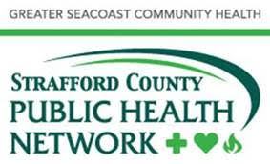

Attestation

Seacoast & Strafford County COVID-19 Vaccination Clinics

The below document must be signed in order to volunteer/work at a COVID-19 Clinic within the Strafford County and Seacoast Regions. By signing below, you affirm that they have reviewed and understand the provided training.

I understand that Job Action sheets will be provided by the clinic administrator on site. Should I have questions I will ask at that time before performing said job.

Based on my own credentials and the provided training, I feel prepared to perform the various job functions within the vaccination clinic.

I am aware if I have any questions, I am to direct them to the clinic administrator on site.

Date:

Name:

Credentials (medical if administering vaccine):

Electronically signing and sending this form will create an electronic record indicating the above and replace a hard signature. If receiving JIT (Just-In-Time) training on site please sign below.

Signature_ _________________

