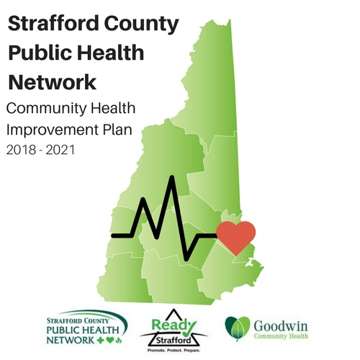

Acknowledgements

The Strafford County Public Health Network wishes to acknowledge the hard work and dedication of its community partners and former and current staff: Elizabeth Clark, Dean LeMire, Melissa Silvey, Dave Hutchinson, Alissa Cannon, Ashley Ciampa and Corinna Moskal. Consultant Michelle Landry, MPH was invaluable in being the primary author of the CHIP.  Without their vision, research and diligent work in reviewing the Network members input and determining the best approach towards impacting public health in Strafford County this Community Health Improvement Plan would not have been possible.

We would like to acknowledge the PHAC Executive Board for their leadership and commitment throughout the past two years, they include: Jeni Mosca, SAU 56; Kathleen Grace-Bishop-UNH Health Services; Janet Laatsch-Goodwin Community Health, Rich Leonard-Pharmacist and Farmer; Mary Wilson-SAU 64; Betsey Andrews Parker – Community Action partnership of Strafford County; Chris Kozak-Community Partners; Ken Robichaud- formerly of  Strafford County; Susan Houghton-Wentworth Douglass Hospital; Wendy Presley- Frisbie Memorial Hospital; Liz Durfee- Strafford Regional Planning; Rene` Philpot-Homemakers Health Services; Terry Johnson-Healthy NH & NH HEAL Coalition; Anne Grassie- Rochester Child Care; Nick Toumpas- IDN Region 6; John Burns- SOS Recovery Community; Carrie Conway- Strafford County; Chris Kozak- Community Partners; Michelle Hanson- Wentworth Douglass Hospital; Marc Hiller- UNH; Sharon Drake- Southeastern New Hampshire Services.

The Community Health Improvement Plan would not have been possible without the 165 stakeholders who came together through Network meetings and workgroups to develop and refine the CHIP to meet Strafford County’s needs and feasibility.

A final thank you goes to Goodwin Community Health, it CEO-Janet Laatsch, its Board of Directors, led by Dr. David Staples, DDS and our Chief Financial Officer, Erin Ross, who work behind the scenes to ensure that the Public Health Network of Strafford County is always “partner-centered” and always has the health and wellness of Strafford County citizens in its mission each and every day.

**“Never doubt that a small group of thoughtful, committed citizens can change the world; indeed, it's the only thing that ever has.”  Margaret Meade**

Respectfully submitted,

Cathy Smith, MSN, RN, Director of QI and Population Health

Goodwin Community Health

February 15, 2018

# **Table of Contents Page**

# **I. Executive Summary 4-5**

# **II. Community Profile 6-7**

# **III. The Mission of Strafford County Regional Public Health Network 8**

# **IV. Community Health Improvement Planning 9-13**

# **V. Community Priority Areas**

# **Priority 1: Substance Misuse, Prevention, Treatment and Recovery 14-24**

# **Priority 2: Mental Health 25-33**

# **Priority 3: Obesity/Nutrition 34-44**

# **Priority 4: Emergency Preparedness 45-49**

# **Priority 5: Heart Disease and Stroke 50-53**

# **Appendix A: Workplan – Substance Misuse Prevention,**

# **Treatment and Recovery** **54-55**

# **Appendix B: Workplan – Mental Health 56-57**

# **Appendix C: Workplan – Obesity / Nutrition 58-59**

# **Appendix D: Workplan – Emergency Preparedness 60-61**

# **Appendix E: Workplan – Heart Disease and Stroke 62-63**

# **Appendix F: Workplan – Assets and Gaps Table 64-68**

***Appendix G:* Contact Information 69**

# Introduction: Strafford County Regional Public Health Network

The Strafford County Regional Public Health Network is a collaboration working to enhance and improve public health-related efforts within the region. The Strafford County Regional Public Health Network is hosted by Goodwin Community Health (GCH), which is a Federally Qualified Health Center that serves over 10,000 patients.

The PHAC Executive Committee will utilize the framework of Health Impact Assessment (HIA) to prioritize public health related disparities in Strafford County. Strafford County ranks 8 of 10 in Health Outcomes and Factors as reported in the 2017 [County Health Rankings](http://www.countyhealthrankings.com/). The PHAC Executive Committee is committed to improving health disparities over time by implementing population level strategies to improve health outcomes.

# Executive Summary

Throughout 2013 and 2014, the Strafford County Public Health Advisory Council (PHAC) comprised of a network of community stakeholder organizations, convened to prioritize the region’s most pressing health needs. Analysis of health and demographic data, and input from community stakeholders and residents, as well as Frisbie Memorial and Wentworth-Douglass Hospitals’ Community Health Needs Assessments, completed in years 2012 and 2013 respectively, and New Hampshire’s State Health Improvement Plan, led to the identification of five Priority Areas.

The Strafford County Community Health Improvement Plan (CHIP) is as an action-oriented strategic plan and framework to be used to leverage resources and to engage and mobilize community stakeholder organizations to address barriers and opportunities to improve community health.

The Strafford County CHIP is the first systematic, countywide effort in place to address population-level health problems in Strafford County to be used by health, education, government, and social service organizations to guide programs and services that promote health, improve quality of life, and attenuate vulnerabilities.

A confluence of predisposing intrinsic determinants and individuals’ lifestyle and behavioral choices, as well as mitigating circumstances, work in tandem to make possible a milieu conducive to afflicting societies most vulnerable, often with long-lasting effects[1]. To affect positive change, we must apply a systems-thinking paradigm. Ultimately, the goal is multi-sectoral collaboration among stakeholders to ensure that adequate resources are allocated appropriately and efficiently for sustained prevention and intervention initiatives so as to improve the health of future generations.

Each of the five prioritized areas of need is assigned goals, objectives and measures, as well as recommended evidence-based strategies. Each area of priority is equally important to improve the health and wellbeing of Strafford County residents. Sustained collaboration among multi-sectoral stakeholder organizations is essential to ensure that mechanisms are in place and available for ongoing data collection and aggregation, as well as assessment over the long-term. It is through these initiatives that we can promote and sustain effectively healthy environments for all residents.

# NH Regional Pubilc Health Networks.jpgCommunity Profile

|  |  |
| --- | --- |
| Towns Served: | |
| Dover | Lee |
| Madbury | Durham |
| Rollinsford | Somersworth |
| Strafford | Milton |
| Middleton | Farmington |
| New Durham | Barrington |
| Rochester | County of Strafford |

Strafford County is situated in the greater Seacoast region of southern New Hampshire and borders southern Maine. Within the County’s 368.8 square miles, there are thirteen municipalities with substantial demographic and socio-economic diversity[2]. Between 2000 and 2010, Strafford County saw a 9.6 percent increase in population compared to the state’s increase of 6.5 percent during the same time period[3]. In 2014, Strafford County’s population was estimated at 125,604 residents; a two percent increase from the 2010 Census population data[4].

Strafford County is home to the University of New Hampshire, which has enrolled nearly 15,000 undergraduate and graduate students. The age distribution in Strafford County parallels that of the state. In 2013, children under age 5 made up 5.2 percent of the population, while persons under 18 years made up 19.7 percent[5]. The fastest growing segment of the population was persons 65 years and older accounting for 23.4 percent of the population[6].

Strafford County’s ethnic characteristics mirror the state, with 92.1 percent White alone, non-Hispanic or Latino living in the County[7]. The median income in Strafford County is $59,290 compared to the State’s $64,064[8], and the percentage of people living below the Federal poverty level is 10.5 percent compared to the state’s 8.7 percent[9]. The top five Census tracts reporting the greatest percent of the population living under the Federal poverty level are located in Rochester, with some areas reporting upwards of 3.4 percent of the population. Population density overall in Strafford County is 333.7 persons per square mile compared to 147.0 for state, with the highest population density recorded in Dover, at 2,336 persons per square mile[10].

Of the state’s ten counties, Strafford County is ranked eighth (10 being worst) in both Health Behaviors and Health Outcomes measures[11]. Key Lifestyle Behaviors’ indicators, such as the percentage of people using tobacco and alcohol, are overweight or obese, or are physically inactive affect negatively the overall Health Behaviors ranking[12].

*The County Rankings and Roadmaps* model asserts that certain Lifestyle Behaviors, such as tobacco use, diet and exercise, and alcohol and drug use accounts for 30 percent of Health Outcomes, such as length of life and quality of life[13]. Socioeconomic factors such as education level, employment status, and household income also affect health outcomes[14].

Through the *Rankings* model, multi-stakeholders understand better the external factors that influence behavior and affect health outcomes. This data can be used to help mobilize stakeholders to identify how best to improve health outcomes in their county[15].

The burden of chronic disease in Strafford County is great. For example, 31% of adults are obese[16]. Obesity is a major risk factor to developing heart disease and stroke.[17]Strafford County ranks third out of 10 counties in the number of adults diagnosed with, and hospitalized for, coronary heart disease, 5.65 percent and 18.19 per 10,000 admissions respectively[18]. Just as alarming is the burden of stroke, which is significantly higher than the rest of the state in which 20.49 percent of hospital admissions were attributed to stroke. What’s more, Strafford County ranks third of 10 counties for stroke mortality, with 204 deaths from 2009-2013[19] and has a higher rate, 301.3, of premature age-adjusted mortality among residents under the age of 75 compared to the state’s rate of 280.8.

Strafford County ranks poorly also - eighth for self-reported quality of life and health status measures in which 14 percent of the County’s adult population reported being in *poor to fair health* during the past 30 days compared to the state’s 11 percent. Also during the past 30 days adults reported that the number of days their *Mental Health* was 3.7 days compared to the state’s 3.3 days[20].

# The Mission of the Strafford County Regional Public Health Network

Our Vision: We envision a vibrant, healthy and productive community that values health and wellness and as a result our citizens thrive and prosper.

OUR MISSION: The mission of the Strafford County Regional Public Health Network is to *improve the health, wellness, and quality of life for all individuals in Strafford County.*

The Executive Board of the Public Health Advisory Committee (PHAC) has utilized the framework of the National Association of County and City Health Officials (NACCHO) and the County Health Rankings and Roadmaps, a Robert Wood Johnson Foundation program to prioritize public health related disparities in Strafford County.

The PHAC Executive Committee is committed to improving health disparities over time by implementing population level strategies to improve health outcomes.

# Community Health Improvement Planning

introduction to Community health improvement planning

The Strafford County Community Health Improvement Plan reflects the collaborative efforts of stakeholder organizations with the shared vision to improve health and quality of life to its residents.

The Strafford County PHAC and its network of community stakeholder organizations engaged to:

* Identify and evaluate health issues
* Inventory community assets and resources
* Identify community perceptions
* Develop and implement coordinated strategies
* Provide information to community members
* Help plan effective interventions
* Develop measurable health objectives and indicators
* Provide a baseline to monitor changes and trends
* Build partnerships and coalitions
* Identify emerging issues
* Prioritize five regional public health priorities
* Develop a Community Health Improvement Plan
* Cultivate community ownership of the process

Community Health Assessment (CHA)

Community Health Needs Assessments are important tools used to assess the overall health of a community. The Community Health Needs Assessments of Frisbie Memorial Hospital and Wentworth-Douglass Hospital utilized quantitative and qualitative data sources to understand better the health needs in Strafford County. Primary sources included numerous focus groups consisting of community leaders as well as residents from target populations.

To understand better the demographic characteristics of Strafford County, economic, health, and educational data sets were retrieved from the following entities:

* U.S. Census Bureau
* Centers for Disease Control and Prevention (CDC)
* Youth Risk Behavior Surveillance System (YRBSS)
* Behavioral Risk Factor Surveillance System (BRFSS)
* US County Health Rankings and Road Maps
* NH Department of Health and Human Services
* American Community Survey
* NH DHHS Web Reporting and Querying System (WRQS)
* NH Division of Public Health Services

The following community stakeholder organizations were engaged in the CHNA process for Frisbie Memorial Hospital (FMH) and/or Wentworth-Douglass Hospital (WDH):

* City of Rochester
* Frisbie Memorial Hospital Providers
* Strafford County Community Action
* The Monarch School
* Rochester Police Department
* The Homeless Shelter of Strafford County
* Rochester Visiting Nurses Association
* The Homemakers
* ServiceLink of Strafford County
* Health and Safety Council of Strafford County
* Wentworth-Douglass Hospital Administration & Board of Directors

# Initial CHIP Planning Steps

In March 2014, the Strafford County Public Health Advisory Council (PHAC), together with a network of community stakeholder organizations, convened to prioritize the region’s most pressing health needs. Analysis of health and demographic data, and input from community stakeholders and residents, as well as Frisbie Memorial and Wentworth-Douglass Hospitals’ Community Health Needs Assessments, completed in years 2012 and 2013 respectively, and New Hampshire’s State Health Improvement Plan, led to the identification of five Priority Areas.

Top prioritized needs identified in the Frisbie Memorial Hospital CHNA (2012):

1. Access to resources to address Risky Behaviors (smoking, physical inactivity, substance misuse, teen pregnancy, poor nutrition, bullying)
2. Access to treatment/rehabilitation for drug and alcohol dependence
3. Access to behavioral health services (hospitalization and outpatient services)
4. Increased attention to chronic ambulatory care sensitive conditions (diabetes, COPD, CHF, oral health, asthma, hypertension)
5. Access to safe and affordable housing

Top prioritized needs identified in the Wentworth-Douglass CHNA (2013):

1. Increased access to behavioral health services
2. Access to transportation services
3. Access to primary care
4. Access to education and prevention programs
5. Access to health insurance/resource information to consumers

Prioritization Tools and Resources:

In March 2014, the Community Health Institute (CHI) was contracted to provide a data report that Network members could review on a variety of health related issues. CHI sent two facilitators to Strafford County’s second bi-annual Network meeting, in March 2014. Over the course of four hours members reviewed the data and prioritized three areas of importance:

Substance Misuse Treatment and Recovery

Mental Health

Obesity and Nutrition

Work commenced in Network meetings and a variety of community engagement opportunities to refine and prioritize strategies and activities related to these three public health issues in Strafford County. In 2015, guidance was received by the Public Health Network from NH DPHS regarding the need to incorporate Emergency Preparedness and Substance Misuse into the CHIP. Since Substance Misuse Treatment and Recovery were identified by key stakeholders, the region set out to identify one addition priority area to incorporate into the CHIP- Heart Disease and Stroke as well as revisit prioritization, planning strategies and activities for Emergency Preparedness and the inclusion of prevention in the Substance Misuse priority. The following is a table of some of the organizations represented during the planning process.

|  |  |  |  |
| --- | --- | --- | --- |
| Frisbie Memorial Hospital | Wentworth-Douglass Hospital | Community Partners Behavioral Health Services | Ready Strafford |
| Goodwin Community Health | Rochester Housing Authority | Rochester Police Department | Dover Coalition for Youth |
| Cornerstone VNA | Strafford Regional Planning | Rochester Child Care Center | Health & Safety Council of Strafford County |
| Community Action Partnership | McGregor Emergency Services | City of Dover Fire | Mayor’s Office, Portsmouth |
| Strafford County School District’s | ONE Voice | LifeWise Community Program | Foundation for Healthy Communities |
| The Homemakers | Hamel Substance Abuse | Triangle Club | Division of Health and Human Services |
| HOPE | People Care | Tri-City Co-Op | Pinewood HealthCare |
| Southeastern NH Services | Strafford County Sheriff | Area Fire Departments | Municipalities |

# Revision Steps

In July of 2017, the Strafford County Public Health Advisory Council (PHAC), began to realize there were some revisions that needed to be made to the existing objectives to our community health improvement plan. We felt in addition that there were insufficient updates to data already existing in our plan, which lead us to just revise and revisit only our goals and objectives. It is our mission to execute a new community health assessment as well as a wider revision of data points, and partner focus groups for the next iteration of our Community health Improvement Plan. With this plan expiring in 2021, we will be conducting all assessments and planning steps in 2020, after a new State Health Improvement Plan is finished as a guide to drive our work in our separate county.

# Community Priority Areas

The five public health priority areas chosen by the Strafford County Network include:

1. Substance Misuse, Prevention, Treatment, and Recovery*
2. Mental Health*
3. Obesity and Nutrition*
4. Emergency Preparedness
5. Heart Disease and Stroke

*Denotes priorities set by Public Health Advisory Council Network members

# Priority Area 1: Substance Misuse, Prevention, Treatment, and Recovery

## Background

Approximately 105,000 individuals (9% of the population over 12 years of age) in New Hampshire meet the American Psychiatric Association (APA) diagnostic criteria for substance use disorders (SUD). Approximately 5,000 people receive SUD services through contracts administered by the Department of Health and Human Services (DHHS) Bureau of Drug and Alcohol Services (BDAS). New Hampshire is consistently ranked highest in the nation for alcohol consumption among adults and young people per capita, and among the highest for illicit drug use, while access to treatment for resident’s remains among the lowest in the U.S[21]

The consequences of substance misuse on our region are substantial, as is its toll on emotional, mental, physical, and economic wellbeing of individual residents[22]. Of particular concern is the rate by which young adults across New Hampshire are dying as a result of overdosing on heroin and the prescription narcotic Fentanyl. From 2010 to 2013, heroin use among NH residents surged dramatically and the number of heroin-related overdose deaths increased from 14 to 45 deaths. The total confirmed number of opioid overdoses resulting in death in 2014 is 326, of which 128 involved Fentanyl, a prescription opioid fifteen to twenty times more potent than heroin that is being used to ‘cut’ individual batches of heroin for sale. The medical examiner's office has reported more than 210 overdose deaths so far in 2015 as of late August 2015.[23]

In addition to public health impacts, the economic toll sustained in our state resulting from substance misuse and addiction is grave. In 2012, costs associated with substance misuse in NH for workplace productivity (impaired productivity and absenteeism) was $1.15 billion. The economic burden for healthcare services, including substance misuse treatment, medical care, and insurance administration totaled nearly $266 million.[24]

Costs associated with the criminal justice system, including police protection, corrections, cost to crime victims, and victim productivity loss reached $284 million[25].

In 2012 New Hampshire became the 49th in the nation to implement a Prescription Drug Monitoring Program aimed at tracking and reducing unnecessary prescriptions of addictive drugs. In 2014, New Hampshire still ranked third in the nation for prescriptions of long-acting opioid pain relievers. Now, in 2015, more prescribers are complying as a condition for license renewals, prescriptions are being systematically controlled. Looking at the trends in neighboring states such as Vermont and Massachusetts, ours is poised to see even more of its residents turning to heroin as prescription opioids become scarce.

The opioid epidemic is seminal to the concerted effort now taking place in communities throughout the state. Organizations across multiple sectors, including law enforcement and health care, have engaged to identify how best to address this public health problem across the spectrum of care.

As communities across the state continue to grapple with the rising prevalence of substance misuse and addiction rates, Regional Public Health Networks, comprised of multi-sectoral organizations including health and medical, safety and law enforcement, education, business, and government domains, will employ collaborative and capacity-building efforts to leverage the resources necessary to increase access to and make available substance misuse prevention, intervention, treatment, and recovery support programs and services among youth and adults.

In September 2014 through August 2015, five focus groups were conducted locally to ascertain among select populations in Strafford County their experience or perceptions about Substance Misuse (Refer to Call Out Box).   
  
Findings implicate environmental, emotional, and mental health factors as having the greatest influence on individual behavior, including family dynamics, lack of supports, genetics, and other stressors and conditions.  
  
There was consensus among participants within each focus group that more school-based education is needed with a focus on the negative impacts of substance misuse. According to one participant from Dover Children’s Home, “It would be nice to have a continuous progressive structure of education regarding the topic of alcohol and drug misuse throughout the entire levels of grades like they do for other subjects.” Similar sentiments were shared among participants in the TC Strafford County Corrections male and female populations. Specifically, there was a perceived inadequacy of substance misuse education in schools; a need to begin educating youth about substance misuse earlier on in the lower grades was endorsed by most. Some participants suggested that substance misuse education should be taught to children as early as kindergarten.  
  
But today’s youth in Strafford County do seem to perceive harm from drinking and using drugs. Nearly 90 percent reported they are at risk if they take a prescription drug without a prescription, according to the Strafford County Youth Risk Behavior Survey collected Spring 2015; ninety-four percent of Strafford County middle schoolers believe their peers disapprove of this same behavior. Almost none surveyed believe their parents condone drinking daily or using any drugs at all, and 84 percent believe their friends frown upon regular alcohol use.   
  
Though our focus group participants noted comprehensive school-age drug and alcohol education as a primary concern, current regional data suggests that the message about harm associated with substance misuse is being heard and not heeded. Despite the perceived harm and social pressure to not misuse substances among middle-schoolers, the rate of substance misuse among high school students in Strafford County surpassed the State in all areas except using a prescription drug without a doctor’s prescription .[26]  
  
Where is the disconnect?  
  
Most focus group participants agreed that a person’s home environment played a significant role in whether or not youth will misuse substances. Several participants acknowledged that children model after their parents’ behavior. As stated by one participant from Dover Children’s Home, “A lot of kiddos that are currently residents at this facility are here because of substance misuse by the parents in the home.” Another participant added, “It becomes normal, and a familiar environment can make the child more vulnerable to substance misuse.”   
  
Other participants questioned whether external influences even play a role for some, suggesting that a person’s genetic predisposition to substance misuse trumps all other factors. According to one participant, “Some kids in here (Bonfire) were brought up like sh**; other kids were brought up well, and they’re both heinous IV heroin users….”   
  
Most participants indicated feelings of disconnectedness, social anxiety, and/or mismanaged stress as playing large roles in their need to misuse alcohol and drugs.  
  
*48.4% of middle school students reported being bullied on school property  
*18.1% of middle school students reported self- harm  
*27% of middle school students have felt sad or hopeless for two or more weeks within the past year  
  
Prevention remains a critical priority for Strafford County, and just as important will be this region’s response to an existing opiate crisis. The scope of the problem and its damages is huge; one indicator of the prevalence of opioid misuse is admissions data from treatment centers based on patients’ region of residence. According to the New Hampshire Drug Monitoring Initiative, 64 Strafford County residents were admitted to treatment programs for opiate addictions between January and February of this year. Two Strafford County cities have consistently been ranked among the top ten in New Hampshire for emergency responder administration of Narcan since 2011. Strafford County accounted for 90 incidents involving Narcan by emergency medical responders between March and May of this year.[27]  
  
There were 56 deaths by opioid overdose in Strafford County between 2009-2013.  
Somersworth police claimed in late June that there had been more than 50 overdose calls by that point in 2015, and 14 in June alone, 6 of which resulted in death. [28]

**Substance Misuse Focus Groups**

* Bonfire Sober House
* Therapeutic Community Program of Stafford County Corrections ( Male)
* TC SCC (Female)
* Dover Children’s Home
* Leadership Roundtable

Strafford County’s only inpatient treatment program, Southeastern New Hampshire Services, recently cut its available number of beds per licensing and Medicaid requirements that are putting the agency’s future as an inpatient treatment program in jeopardy. This year Southeastern reduced the beds in its 28-day treatment program from 14 to 10 to comply with space regulations. Other requirements needed to transition from State to Medicaid funding will cost an estimated $500k and are due in 2016 with no proposed funding source or resolution to the issue.  
  
“There were 324 overdoses last year, and there’s still a pile of autopsies to be done…”  
“Five of my friends overdosed last year…”  
“I’ve seen so many people come and go…” (Bonfire Recovery Services residents)  
  
Many focus group participants agreed that as their addictions progressed, substance use took priority over all other valued parts of their lives. One participant shared, “We are people who are smart, have ideas…at one point, I was on a path to where I want[ed] to be, but drugs pushed me off my potential.” Another added, “Whatever you live to do…becomes secondary to your first love (drugs).”   
  
Stigma associated with untreated SUD ­­­was a common theme heard among the substance use focus groups. Several participants agreed that the longer they lived in active addiction, the worse their behavior became, and the more marginalized, criminalized, and alone they felt within their families and communities. Increasing feelings of shame accompanied unsuccessful attempts to moderate or stop their substance use, according to some. Participants referred to a diminishing “window of willingness” during which they were emotionally capable of seeking or accepting help of any kind, and emphasized the need for treatment to be readily available when people with SUD “make the call.”   
  
One of the Bonfire participants described a need in our region to have a person stationed in the emergency rooms who is there to offer support to the person recovering from the overdose experience. Other participants agreed with this idea and went on to further discuss how it would be beneficial to the person who is experiencing the overdose crisis.   
“My insurance wouldn’t even cover a medical detox because essentially you can’t die from heroin withdrawal….”  
“I called detox and they said we have no beds….”   
“The grace period of someone’s willingness to getting clean can be very small, so having to call treatment centers for a week to try and get a bed is not encouraging people to get clean….” –Bonfire

**Other regional data**  
In summary, we have identified the following local shortages and barriers to substance misuse aversion, treatment, and recovery:

|  |  |  |  |  |  |
| --- | --- | --- | --- | --- | --- |
| **Themes throughout focus groups held with Strafford County** | | | | | |
| Coping skills | Access to mental health services | Number treatment beds | Funding for new or existing programs | Insurance restrictions or limitations | Follow-up or continuum of care |
| Sober living opportunities or halfway houses for women | Affordable sober living opportunities or halfway houses for men | Crisis intervention for opiate overdose survivors | Caregivers with access to Narcan to help prevent overdose deaths | Inpatient treatment duration not long enough | Reducing the stigma related to substance abuse disorders |

To effectively address substance misuse and addiction in Strafford County, prevention, treatment, and recovery supports need to be in place. PHAC and network stakeholder organizations must establish a well-coordinated and sustained effort in implementing a comprehensive and systemized community health improvement plan that includes prevention, treatment, and recovery supports.

Regional Assets & Gaps

Though our substance abuse problems grow in Strafford County, our assets are many and growing as well. Below is a list of resources known to be active. Highlighted are groups with particularly high indicated readiness for strategy implementation per their visible engagement with local and state-level planning meetings and initiatives or known activities of expansion.

Below is the PARTNER Tool results for Substance Misuse Prevention efforts in Strafford County, and the display demonstrates a strong inter-connectedness among partners in the region to address this issue.

|  |  |  |  |  |  |
| --- | --- | --- | --- | --- | --- |
| YOUTH AND PARENT EDUCATION | INTERVENTION | | TREATMENT | | RECOVERY |
| Opioid Taskforce | Diversion programs | | Medication Assisted Treatment | | HOPE for NH Recovery |
| People Care | SBIRT | | Southeastern NH Services | | Recovery Coaching Academies |
| Life of an Athlete | ASAP | | ROAD to a Better Life | | AA/NA (12 step) |
| Dover Youth to Youth | Teen/ adult drug court | | Addiction Recovery Services | | Bonfire Recovery Services |
| Community commissions | Mental health court | | Counseling | | Triangle Club |
| Rec. department | Brief intervention | |  | | IOP alumni groups |
| prescriber education | CFS probation/parole | |  | | 12 Step Yoga |
| Child sexual abuse/ SASS | Head start | |  | |  |
| Opioid Taskforce | Primary care | |  | |  |
| ASAP | Care coordination | |  | |  |
| SBIRT | EMS | |  | |  |
| after school programs | Home visiting/ DCYF | |  | |  |
|  | NHEP | |  | |  |
|  | REAP | |  | |  |
| LOCAL GROUPS THAT COULD CONTRIBUTE | | | | | |
| Courts | Police | Family | | Lawyers | |
| Hospitals | Schools | Advocacy | | Recovery Support/Sober Living | |
| Funders | Med. Providers | Local businesses | | Politicians | |
| Opioid Taskforce | Southeastern NH Services | Churches | |  | |
| RESOURCES NEEDED | | | | | |
| |  |  |  |  |  | | --- | --- | --- | --- | --- | | DFC funding | Stop Act | Drug Court | Community Benefits program | Juv. Justice | | Private insurance | Public health | SAMHSA | NH Charitable Fund | S.V. prevention | | EAP’s | TANF | Non-profits |  |  | | | | | | |

# Goals, Objectives and Strategic Approach

|  |  |
| --- | --- |
| Goal | **Strengthen coordination and communication among community health partners to support Substance Misuse Prevention, Treatment, and Recovery initiatives.** |
| Objective 1: | **Increase education and development opportunities in the area of prevention in Strafford County by providing 4 different educational platforms by the end of FY 19.** |
| Objective 2: | **Use continuous updating of information and dissemination to distribute a total of 2,000 resource guides at community events and activities in Strafford County by end of FY 19.** |
| Objective 3: | **Increase the number of recovery coaches with Motivational Interviewing trainings by collaborating with partners to host at least 2 MI trainings in Strafford County by the end of FY 19.** |
| Strategic Approach  STRATEGY 1: Work in collaboration with PHAC partners to identify opportunities to increase capacity of treatment and recovery workforce to address Substance Misuse Prevention, Treatment and Recovery initiatives  STRATEGY 2: Continued updating and research of material to ensure all citizens know services in Strafford County for Prevention, treatment, and recovery.  Strategy 3: increase training opportunities to enhance workflows and capacity of recovery coaches | |

## Summary

OBJECTIVE I: Increase education and development opportunities in the area of prevention in Strafford County by providing 4 different educational platforms by the end of FY 19.

Through conversations with prevention partners as well as PHAC members, it has been recognized that training and educational opportunities are lacking in Strafford County. Prevention seems to have taken a back burning to the world of recovery and as a Public Health Network we believe they work hand in hand. Through providing more training opportunities, more Strafford County residents will be aware of prevention and ways to get involved and play a role in their community.  
  
OBJECTIVE II: Use continuous updating of information and dissemination to distribute a total of 2,000 resource guides at community events and activities in Strafford County by end of FY 19.   
  
ONE Voice aims to work with PHAC to increase capacity of treatment and recovery workforce by training peer support stakeholders in Recovery Coaching and Ethics, by developing a summer learning series for hospital staff to learn more about stigma and support patients with SUD, and by offering training for PHAC members on SUD trends, data, and interventions that can be implemented among various sectors.  
  
OBJECTIVE III: Increase the number of recovery coaches with Motivational Interviewing trainings by collaborating with partners to host at least 2 MI trainings in Strafford County by the end of FY 19.

Motivational Interviewing has been shown to be utilized in a variety of settings to help to create a common messaging of intervention and conversation for patients and clients. Motivational interviewing has been an optional training in the past for recovery coaches but has shown to be a key concept for their practice. With funding, we are hoping to increase the number of trainings that can be offered in Strafford County to get the majority of Certified Recovery Support Workers trained to be proficient to use in their day to day work.

# Priority Area 2: Mental Health

## Background

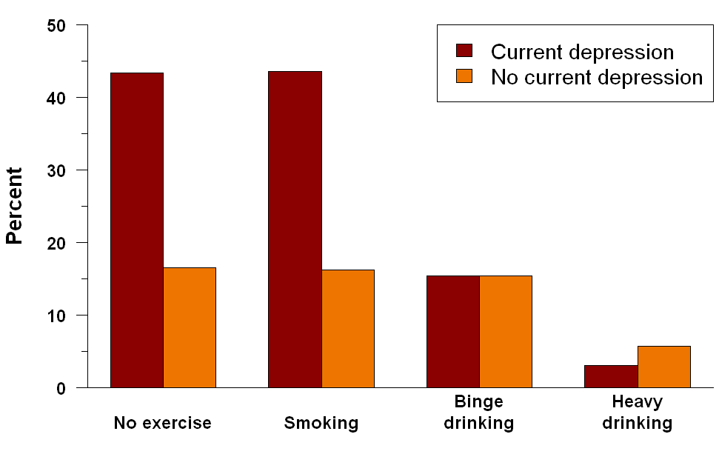Mental health status is essential to personal wellbeing, interpersonal relationships, and being a productive employee in the workplace and member of the community[29]. However, without treatment, mental health disorders are among the most debilitating health conditions[30]. Last year 45 million adults in the United States were diagnosed with a mental illness[31]. Persons with a mental illness have an increased risk of engaging in risky behaviors such as smoking, binge drinking, and not exercising. As a result, a person with a mental illness is at an increased risk for having co-occurring substance use dependence as well as developing chronic health conditions which can make it more challenging to receive comprehensive care as they may need to access services from different treatment systems[32],[33],[34].

Figure : Prevalence of Health Risk Behaviors by Current Depression Status in NH, 2006

For example, 37 percent of U.S. adults with a mental health disorder in the past year reported smoking cigarettes compared to 22 percent of adults who smoked with no mental illness[35]. Rates for binge drinking (five or more alcoholic drinks in two hours time) are also higher in adults with a mental illness where 30 percent report binge drinking, compared to 24 percent who binge drink without a mental illness[36][37].

# In New Hampshire the number of people with current depression reporting being physically inactive and smoking cigarettes was significantly higher than persons without depression. However, the prevalence of New Hampshire adults reportedly having current depression did not show higher rates in binge or heavy drinking (Figure 2)[38].

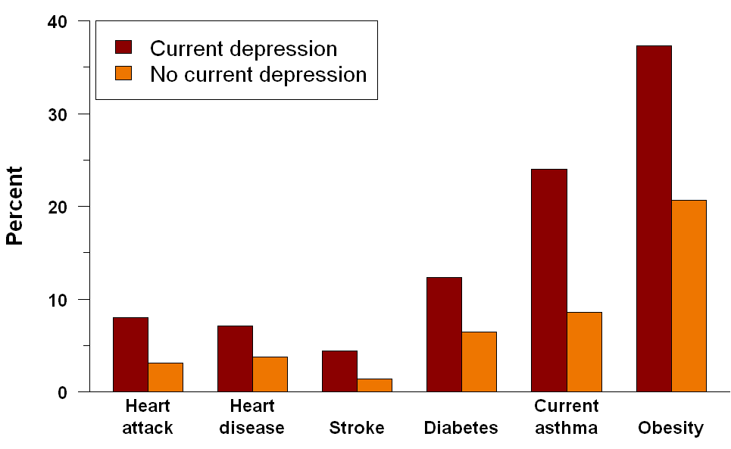In the 2011 New Hampshire State Health Profile, seven percent of adults reported having had current depression, with higher rates among the female population, persons in the lower income brackets, and those out of work[39]. Additionally, 17 percent of adults reported having had depression at some point in their life.

From 2000 to 2009, there was a significant trend toward the negative for the number of mental health outpatient and inpatient discharges in New Hampshire[40]. To illustrate, in 2000 the rate of emergency department discharges for mental health was 12.7 percent; in 2007 the rate increased to 14.3 percent. And from 2000-2007, there was a slight increase in specialty hospital mental health discharges, from 3.1 percent compared to 3.3 percent, respectively. What’s more, each month throughout the state there are, on average, 30 emergency visits for mental health issues[41].

Figure : Prevalence of Chronic Health Conditions by Current Depression Status in NH, 2006

A significant barrier to accessing the appropriate mental health services is that of capacity. For instance, adults with co-occurring mental health and substance abuse disorder face substantial challenges to accessing treatment. New Hampshire has the highest per-capital addiction rate in the country and second lowest treatment capacity, attributed in part to a severe reduction in public funding as well as poor reimbursement rates[42], [43].Capacity issues can be attributed also to the fact that licensed drug and alcohol counselor services are not reimbursable[44].

There is one public-run mental health hospital, New Hampshire Hospital (NHH). With only 158 beds, of which 24 are dedicated to children and teens, there is on average22.3 people waiting to be admitted is each month[45]. As a means to increase capacity the state contracts out to 10 mental health centers for treatment throughout the state[46].

A look into the readmission rate at NNH pointedly illustrates a lack of continuity of care upon discharge. For instance, of those patients previously admitted and discharged within 180 days, approximately 18 percent returned to NNH[47]. The cost to treat one person at NNH is significant: $788 per day, or $287,000 per year[48].

Key indicators, such as an increase in the number “of people being incarcerated, higher rates of homelessness, [and] higher rates of people waiting in emergency departments for “beds” point to an inadequate behavioral health infrastructure in which there are too few mental health providers available to meet demand for services[49]. Increasingly hospital emergency departments and county jails have become surrogates for community-based mental health services. For instance, in Strafford County from 2003 to 2007, the rate of mental health-related emergency department visits was 14.3 percent (per 1,000)and sixty percent of jailed inmates at Strafford County jail are being prescribed some form of mental health medication[50],[51].

The ratio of persons with mental illness to mental health providers in Strafford County is 532:1, compared to the proportion at the state level, 412:1. Presently, the state contracts out to one Community Mental Health Center in Strafford County, Community Partners[52]. Still, New Hampshire ranks below the top U.S. performers in which the proportion of persons with mental illness to mental health providers, 386:1[53].Regarding measures of adequacy, the forecast looks bleak (see Figure 3)[54].

Figure Emergency Department Discharges for Mental Health

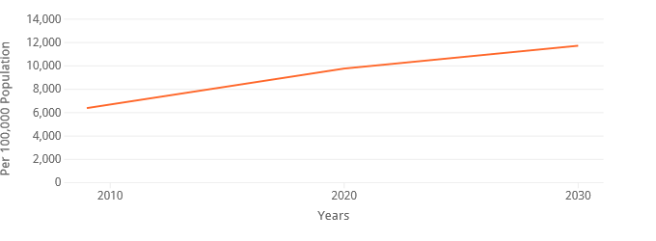Mental Health indicators such as emotional, psychological, and social wellbeing measures illustrate how well a community is meeting the health needs of its residents; poor health outcomes can be linked often to insufficient access to outpatient mental health services[55].

Strafford County ranks eighth (10 being worst) in self-reported quality of life and health status measures where 14 percent of the County’s adult population reported being in *Poor to fair health* during the past 30 days compared to the state’s 11 percent. Also during the past 30 days adults reported that the number of days their *Mental Health was not good* was 3.7 days compared to the state’s 3.3 days[56].

To better understand how members of the community perceive Mental Health issues, four focus groups were conducted:

* Strafford County Corrections TC Males
* Strafford County Corrections TC Females
* Bonfire Sober House
* Dover Children’s Home

Overall participants substantiated those barriers described above. Most were in agreement that too few mental health resources and providers are available to meet the demand. As one participant noted, “it can take up two to three months’ time to get an appointment with a therapist” adding that it was particularly difficult for people on Medicare because “many therapists do not accept it.” There was agreement that it was difficult to maintain continuity of care due to frequent provider rotation. As one participant stated, “I’ve been to five therapists in the last four years…you get to a point where you can confide a lot of things to someone and boom your hit with a different person, different type of therapy, whatever it is.”

Participants agreed that the stigmatization of mental health issues the community was also a barrier to seeking care.

One participant recommended and others agreed that it would be helpful to have an intake specialist available at the emergency department to refer people to mental health resources because they believe that the only way a person can receive immediate help is to go to the emergency room.

There was agreement among many focus group participants that it is easier to obtain a prescription to treat mental illness compared to receiving ongoing counseling with a mental health therapist.

Regional Assets & Gaps

|  |  |  |
| --- | --- | --- |
| Community Partners Behavioral Health | Frisbie Memorial Hospital | Wentworth-Douglass Hospital Health System |
| Goodwin Community Health | Primary Care | School Districts, Strafford County |
| McGregor Memorial EMS | Rochester Pediatric Associates | Wild Irish Farm, LLC |
| Health & Safety Council of Strafford County | The Homemakers Health Services | Rochester Hill Family Practice |
| Rochester Police Department | Rochester Housing Authority | Rochester Youth Reach |
| Family Care of Farmington |  |  |

The measure of collaboration among community stakeholder organizations as depicted in the Partner Tool graphic shows that there are opportunities to increase collaborative efforts to better integrate mental health services in the region.

# 

# Goals, Objectives and Strategic Approach

|  |  |
| --- | --- |
| Goal | **To strengthen coordination and communication among community health partners to support Mental Health initiatives.** |
| Objective 1: | **Increase training opportunities among partners and the Public Health Network from 0 to 5 for all individuals in Strafford County regarding Mental Health awareness and prevention by the end of FY 19.** |
| Objective 2: | **Increase the percentage of patients screened for a mental health illness in all FQHC and primary cares in Strafford County by 5% by the end of FY 19.** |
| objective 3: | **Increase the number of support groups offered in Strafford County for individuals struggling with a Mental Health illness by 1 by the end of FY 19.** |
| Strategic Approach  STRATEGY 1: increase trainings offered in strafford county related to mental health in Strafford County.  STRATEGY 2: increase and support local primary care offices to utilize their mental health screening tool to increase patients screened and interventions applied.  STRATEGY 2: increase and support local primary care offices to utilize their mental health screening tool to increase patients screened and interventions applied. | |

# Summary

Objective one Increase training opportunities among partners and the Public Health Network from 0 to 5 for all individuals in Strafford County regarding Mental Health awareness and prevention by the end of FY 19.

Objective two Increase the percentage of patients screened for a mental health illness in all FQHC and primary cares in Strafford County by 5% by the end of FY 19.

Objective threE Increase the number of support groups offered in Strafford County for individuals that struggle with a Mental Health illness by 1 by the end of FY 19.

# Priority Area 3: Obesity and Nutrition

## Background

Obesity is a chronic health condition primarily attributable to behavioral risk factors such as poor diet and physical inactivity. It is a serious public health problem in New Hampshire, where one in four adults is obese (BMI > 30). Obesity strongly increases the risk of developing chronic health conditions such as heart disease, type-2 diabetes, hypertension, cancer, osteoarthritis and stroke. For example, 17.5% of obese adults have type-2 diabetes, compared to only 4.1% of adults with a healthy weight.[57]

Approximately, 12.6% of 3rd grade students are obese in New Hampshire and 15.4% overweight.[58] Additionally, over 15% of New Hampshire youth aged 10-17 years are obese. Obesity in youth increases the risk of obesity in adulthood which puts them at risk for developing multiple chronic health conditions and premature death. 2

Additionally, a considerable economic burden is associated with obesity. In the United States, 147-210 billion dollars, or nearly 10% of all medical spending, is attributed to obesity-related medical costs based on 2006 data.[59] Moreover, obesity can lead to reduced work productivity and absenteeism. Approximately, $4.3 billion annually is spent on employee absenteeism.[60]

Recent research has found that poor nutrition in children is associated with poor academic performance and that increasing nutrition can lead to more energy, better concentration and improved cognitive performance in students[61].

While poor nutrition and lack of physical activity are often cited as the cause, obesity is a complex condition in which a multitude of influences is at play. What a person chooses to eat is a behavioral choice but also an economic one. Lower education attainment and income levels are strongly associated with obesity in New Hampshire. These social determinants couples with an individual’s physical environment – where one works, lives, and plays – greatly impacts the food options available to that individual and his/her family. For example, parts of New Hampshire have limited access to fresh, healthy and affordable food. These geographical areas are sometimes referred to as food deserts, and tend to disproportionally affect low income urban or rural areas.

Similarly, the physical activity level a person engages in should be considered within the context of where he or she lives. The “built environment,” meaning neighborhoods, streets, buildings, sidewalks, and bike lanes can also play a major role. Some evidence suggests that an environment that is more conducive to physical activity will significantly affect the amount of daily exercise a person gets, and low-income neighborhoods tend to have less recreational areas/ facilities than wealthier neighborhoods.[62][63]

Obesity rates are increasing in Strafford County. According to the 2015 County Health Rankings, 31% of adults are obese in Strafford County compared to an average of 27% in the state of New Hamphire. Overall, Strafford County ranks 8 out of 10 for health outcomes and health factors in New Hampshire.[64]

The Strafford County Public Health Advisory Council Network (PHAC), which consists of approximately 165 stakeholders hailing from Strafford County or working in Strafford County, selected obesity/nutrition as one of Strafford County’s top three health priorities based on data gathered and presented to them by the Community Health Institue (see appendix) and based on fit and feasibility o address in our county.

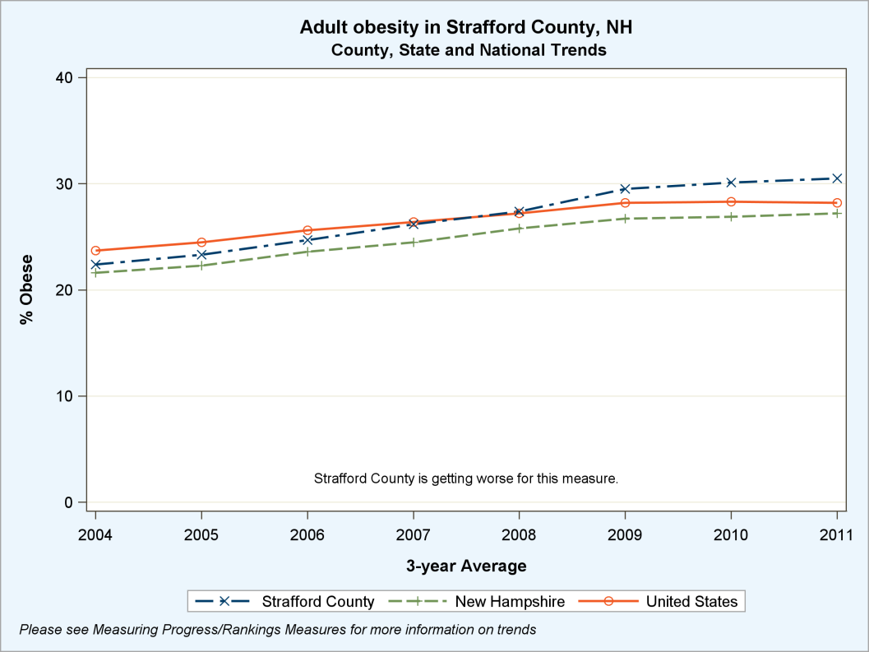

Source: 2015 County Health Rankings

Childhood obesity in Strafford County, particularly among low-income populations, is substantial. This corresponds to findings throughout the state of New Hampshire that low-income areas have higher obesity rates.[65] Strafford County has statistically significantly higher obesity rates among WIC enrolled youth than any other county in the state as depicted in the graph below based on data from the Pediatric Nutrition Surveillance System in 2013.

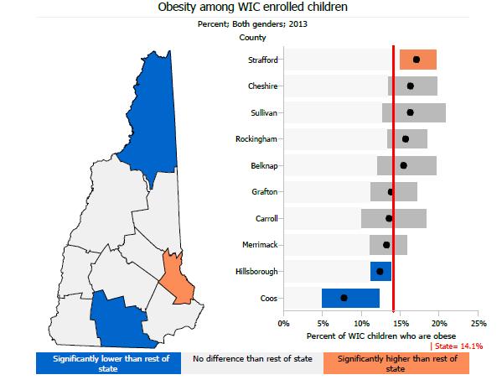

Source: Pediatric Nutrition Surveillance System (PedNSS)

Parts of Strafford County have very high free/reduced lunch rates which can be associated with higher obesity rates unless schools have strong meal standards.[66]

**Eligible for free/reduced lunch**

|  |  |
| --- | --- |
| **Farmington\*** | **46.2%** |
| **Somersworth\*** | **46.5%** |
| **Strafford** | **35.9%** |
| **New Hampshire** | **27.3%** |

*Source: NH Department of Education*

*Districts in the Coordinated School Health Program

Approximately 23% of adults in Strafford County report that they are physically inactive, meaning they do no leisure time physical activity. See graph below:

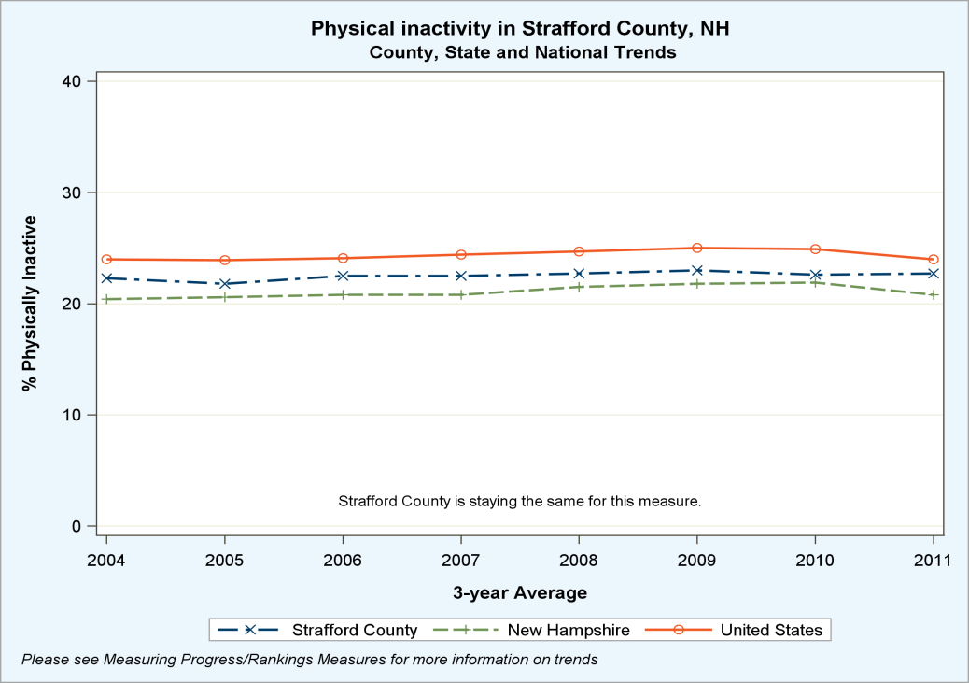

Source: 2015 County Health rankings

High levels of passive activity such as TV and computer time are linked to physical inactivity and obesity. About 47.4% of middle school students in Strafford County reported using a computer for non-school related activities for 3 or more hours on an average school day, and 18.8% reporting watching three or more hours of TV on an average school day according to the 2017 Middle School Youth Risk Behavior Survey[67]. It is recommended to have 2 hours or less of recreational screen time a day. There is a public education campaign called 5-2-1-0 that follows the nutrition and physical activity recommendations. It stands for 5 fruits and veggies, 2 hours or less of recreational screen time, 1 hour of physical activity and 0 sugary beverages a day.[68]

Adequate fruit and vegetable consumption (five or more servings a day) is low among adults in Strafford County with 70.20% consuming less than the recommended 5 servings of fruits and vegetables each day.[69]

Environmental conditions may be impacting nutrition in Strafford County. Parts of Strafford County have low access to fresh produce, known as food deserts. There is a low rate of grocery store establishments per 100,000 population with only 16.24 compared to 19.67 in the state of NH, and 21.14 in the United States. Recreation and physical activity access was also low in Strafford County, with 8.12 per 100,000 versus 15.19 in the state of New Hampshire.[70] See the image below prepared by Strafford Regional Planning depicting the distance to grocery stores throughout Strafford County.

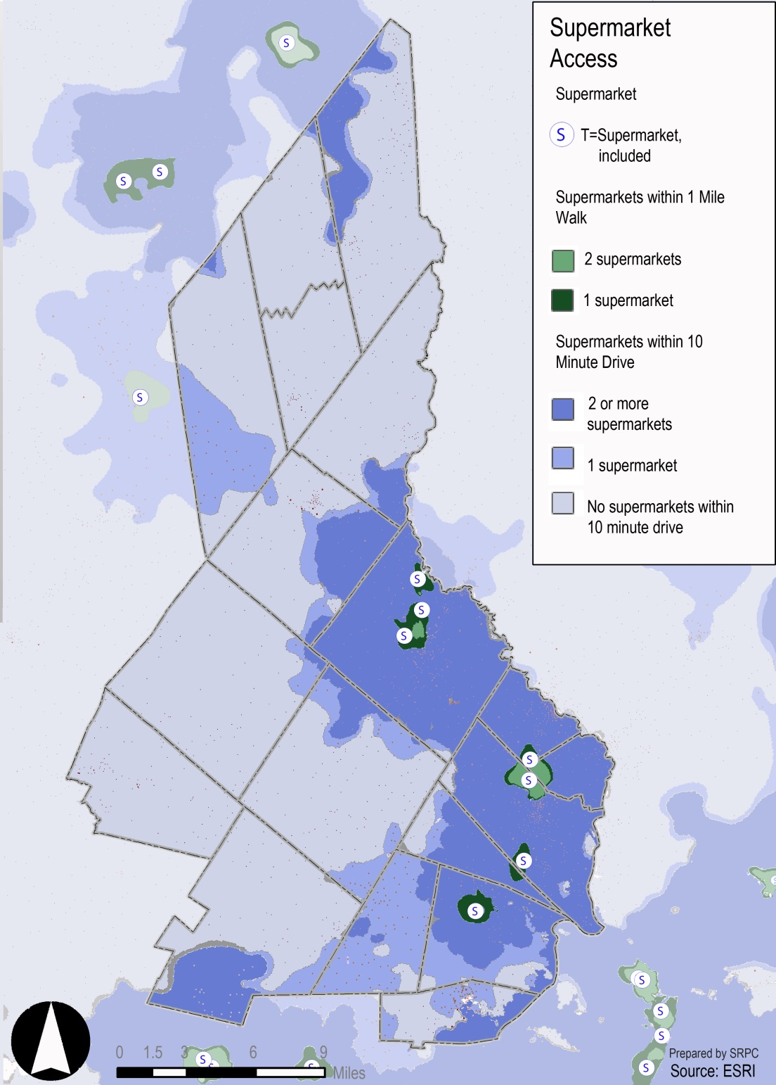

Qualitative themes from two focus groups conducted by the SCPHN supported these quantitative findings that there is a deficiency of healthy food access in Stafford County. The SCPHN conducted two obesity/nutrition focus groups during the summer of 2015. One was held at Frisbie Memorial Hospital (FMH) at the Newborn Baby and Moms group, and one at Goodwin Community Health (GCH) through its’ Empowering Whole Health group.

The lack of accessible healthy food was indicated as a barrier to eating healthy, particularly during the FMH focus group. One participant explained that she lives in New Durham and has to drive into Rochester to get decent options of healthy food at grocery stores. Additionally, participants from the GCH group indicated that there is an abundance of fast foods in Strafford County. Another theme that came out of both focus groups was that there is a strong perception that healthy food is expensive and not convenient. Both focus groups suggested grocery store tours would be beneficial in changing that perception and would help adults figure out what to eat on a budget. To increase convenience the participants suggested more information on simple meals that can be prepared ahead of time and frozen, as well as possibly prepackaged meals that have all of the portioned out ingredients to pick up at grocery stores.

The lack of sufficient free/low cost physical activity opportunities was heavily discussed during these focus groups. A theme that came out of both focus groups was that there is insufficient infrastructure/access to free or low cost physical activity opportunities. As one participant stated:

*I live right on [a busy road] and that road is way too busy to take the stroller out and go for a walk. So if I want to go for a walk or get exercise…I have to go somewhere as opposed to just walking out my door*

Participants in both focus groups felt there needed to be more access to free workout groups and recreational trails that are accessible via bus routes. The FMH focus group felt there needed to be more stroller-accessible trails and the GCH group felt there should be more trails that have physical activity stations similar to a trail in Portsmouth. Additionally, both groups felt that there should be more exercise groups that are oriented for a particular group (i.e. walking groups for persons with diabetes, new moms etc.) that way they can gain support from people in similar circumstances.

Regional Assets

In 2013, Strafford County formed a PHAC of over 165 people who strive to improve public health in Strafford County. This group meets biannually and includes breakouts for individuals to collaborate on Obesity/Nutrition topics. There is also a Public Health Advisory Council Executive Board of high level stakeholders that meets quarterly. Our PHAC Advisory Council determined the following list of assets in Strafford County that are currently working towards addressing this priority:

|  |  |
| --- | --- |
| The Works Fitness Center | Farmers Markets |
| YMCA | Seacoast Early Learning Alliance |
| Partners in health community partners | Schools |
| Rochester Childcare | After School Programs |
| UP Program- after school program | Coop extension NH food strategy |
| People/orgs researching and identifying walkability | 68 hours of hunger program |
| CAP | Gardening meet-ups |
| Community Gardens | Seacoast Eat Local |
| Meals on Wheels | WIC |
| Summer vacation meals 0-19 | Rotary Club |
| Rochester Physician Association | Farm to School |
| Frisbie Memorial Hospital | Goodwin Community Health |

The Strafford County Public Health Network has partnered with Strafford Regional Planning who has very high readiness to improve public health through approaches such as increasing the infrastructure and accessibility of trails and bike paths. We have partnered with Seacoast Eat Local to provide SNAP/EBT and their incentive programs at the Somersworth Farmers Market. Moreover, through our Somersworth Farmers Market initiative we have been able to collaborate with WIC and UNH cooperative extension program, both of which are organizations that are working towards and eager to improve nutrition in Strafford County. Lastly, SCPHN has partnered with two school districts to implement a Coordinated School Health Program (CSHP). CSHP works on improving the health and nutritional well-being of students through coordinated and comprehensive nutrition policies that enhance the school classroom, cafeteria, and community environment, and support lifelong healthful eating habits in turn improves students’ academic performance.

Despite the number of regional assets that our PHAC was able to identify that are working towards this priority area, there is a lack of coordination and collaboration among partners according to the 2014 partner survey results. The partner tool is a web-based social network analysis tool designed by the Robert Wood Johnson Foundation to measure and monitor collaboration among people/organizations. Questions were asked to stakeholders and organizations related to the obesity/nutrition priority areas which did not show many connections among stakeholders/organizations. See image:

# Goals, Objectives and Strategic Approach

|  |  |
| --- | --- |
| Goal | **To promote physically healthy communities by addressing obesity and improving nutrition in Strafford County.** |
| Objective 1: | **Maintain an obesity and nutrition workgroup with at least 5 active members** |
| Objective 2: | **Distribute 3 different platforms that provide education on healthy living by 2019.** |
| Objective 3: | **Collaborate on at least one initiative that increases availability, accessibility, and uptake of healthy foods by the end of FY 19.** |
| objective 4: | **Collaborate on at least one initiative that increases availability, accessibility, and uptake of physical activity by the end of FY 19.** |
| Strategic Approach  STRATEGY 1: continue to foster workgroup to develop and broaden Network Priorities for obesity and nutrition in Strafford County.  STRATEGY 2: work in collaboration with PHAC partners to identify opportunities to increase access to free and low cost physical activity and health food opportunities in Strafford County.  Strategy 3: after opportunities are identified, develop initiatives that can help to defeat barriers to overall health and wellness for all. | |

# Summary

Objective one is to maintain an obesity and nutrition workgroup with at least 5 active members. The Obesity and Nutrition workgroup is a shared space for members to discuss current initiatives we are working on as well as to brainstorm new initiatives to help high risk populations. We recruit members on a quarterly basis to help to increase involvement as well as capacity.

Objective two is to distribute three different platforms that provide education on healthy living to citizens of Strafford County. We will be using past assessments of Strafford County to be able to identify gaps of access as well as availability to live a healthy life. Then through our workgroup and PHAC partners we will develop and disseminate materials of existing free and low cost physical activity opportunities. Additionally, through the workgroup identify needs and potential partners to bolster free and low cost physical activity opportunities throughout Strafford County.

Objective threE and four is to collaborate on at least one initiative to help increase access, availability and uptake of healthy eating and one initiative for active living. We will use past data to determine gaps as well as assets in Strafford County to better understand needs for citizens. We will then determine in our workgroup and PHAC to develop initiatives to address both healthy eating and active living.

# Priority Area 4: Emergency Preparedness

## Background

Public health threats are always present. Communities that “align currently existing resources in order to meet operational needs” are more resilient because they are aware of potential risks and better prepared in emergency situations[71]. New Hampshire has in place collaborative relationships among numerous federal- and state-level agencies, including the Department of Health and Human Services, the Department of Homeland Security and Emergency Management as well as the state’s 13 Public Health Networks[72].Through the Public Health Network system, communities throughout the state can build capacity among stakeholder organizations, including hospitals, health care providers, social service agencies, local government officials, and fire, police, and EMS to ensure a coordinated response to reduce risk during an adverse incident[73].

Results from the 2013 New Hampshire BRFSS Survey on Emergency Preparedness indicate that 32.2 percent of adults believe they are *well prepared* to handle a *large-scale disaster or emergency*, while 53.6 percent were *somewhat prepared* and 14.1 percent were *not prepared*[74].Responses to questions about supply of water, medications, and evacuation plan reveal that 63.2 percent of adults have*3 days water supply* and 82.7 percent have *3days supply of prescription medication*. Only 16.8 percent reported having a *written evacuation plan* in place[75].

The 2013 New Hampshire BRFSS Survey on People with Disability revealed 6.8 percent of people have a health problem that requires special equipment such as a cane, wheelchair, a special bed, or a special telephone[76].Only 2.9 percent of adults reported being blind or having serious difficulty seeing, even when wearing glasses[77]. 9.7 percent reported having difficulty concentrating, remembering, or making decisions because of a mental, physical, or emotional condition. 10.8 percent reported having difficulty walking or climbing stairs. 3 percent have difficulty dressing or bathing[78].

Emergency Preparedness activities are coordinated through Ready Strafford, which is a collaborative network comprised of key Emergency Preparedness and Public Health stakeholders and partners to effectively respond to public health emergencies and threats. Ready Strafford practices an “all hazards” response approach to monitor health status, diagnose and investigate health problems and health hazards, inform public about health issues, mobilize community partners, and enforce laws and regulations that protect health and ensure safety.

Over the past year, Ready Strafford has made progress engaging and collaborating with new partners to continually build community resilience and sustain public health and emergency response systems.

Results from the 2013 New Hampshire BRFSS Survey on Emergency Preparedness indicate 30.7 percent of adults in Strafford County consider themselves *well prepared* in the event of an *wide-scale disaster or emergency*, while 55 percent believed to *be somewhat* and 14.3 percent believed they were *not at all prepared*[79]. Responses to questions about supply of water, medications, and evacuation plan reveal that 62.8 percent of Strafford County adults had a *3 day water supply*, 81.9 percent had *3 day supply of prescription medication*, and only 18.6 percent had *written evacuation plans* in place[80].

The 2013 New Hampshire BRFSS Survey on People with Disability revealed that 4.3 percent of adults report being *blind or having serious difficulty seeing*[81]. Strafford County had the second highest number of adults, 13.8 percent, who had *difficulty concentrating, remembering, or making decisions*, and had also the second highest number of people, 12.6 percent, having *difficulty walking or climbing stairs*[82]. In measuring activities of daily life, 3.6 percent reported *having difficulty dressing or bathing*, and 7 percent reporting having difficulty shopping or going to doctor appointments[83].

# Regional Assets



Partners include:

|  |  |  |
| --- | --- | --- |
| Hospitals | Municipalities including: Fire, Police, and EMS | School districts |
| Strafford County Citizen Corp. | Cornerstone VNA | Community Action Partnership |
| health care providers | community health centers | Community Mental Health |

# Goals, Objectives and Strategic Approach

|  |  |
| --- | --- |
| Goal | **To build community resilience through increased partner involvement and to strengthen and sustain public health and emergency preparedness systems** |
| Objective 1: | **Increase integration of key stakeholder organizations to build capacity to support public health efforts related by having a minimum of 6 partners attend quarterly meetings.** |
| Objective 2: | **Identify and initiate Medical Countermeasure dispensing strategies 5 times by the end of FY 19.** |
| Objective 3: | **Develop at least 4 professional development training opportunities to current partners by the end of FY 19.** |
| Strategic Approach  STRATEGY 1: Collaborate with community organizations to improve the capacity to deliver the Ten Essential Public Health Services.  STRATEGY 2: Conduct outreach to partners to find ways to exercise Point of dispensing (pod)s to practice they are efficient.  Strategy 3: increase education and knowledge to all partners of emergency preparedness. | |

# Summary

Building community resilience, and strengthening and sustaining public health and emergency systems in Strafford County, can be accomplished through three Objectives.

Objective 1**:** Increase the integration of key stakeholder organizations within the public health network that engage in public health emergency planning, training, exercising, and response. PHAC and network partners propose collaborating with community organizations to improve the capacity to deliver emergency preparedness services and planning. To accomplish this objective, we recommend the following activity:

1. Convene and facilitate community partnerships, task forces, or initiatives that foster the ability of first responders to ensure vulnerable populations can recover from an emergency.

Objective 2: Identify and initiate Medical Countermeasure dispensing strategies 5 times by the end of FY 19. PHAC and network partners recommend increasing opportunities to practice a POD and ensure it has the ability to run smoothly in a true emergency. To accomplish this objective, we recommend the following activity:

Objective 3: Deliver at least 4 professional development training opportunities to current partners by the end of FY 19. PHAC and Emergency preparedness partners recommend that increasing the availability of training opportunities subjected around emergency preparedness will help to bolster knowledge and partnerships to form in the region.

# Priority Area 5: Heart Disease and Stroke

## Background

Heart disease remains the largest cause of premature death in the United States and is the second leading cause of death in New Hampshire. In 2008, 1,700 deaths and 5,583 hospitalizations occurred due to heart disease[84].Heart disease includes several types of conditions, the most common being coronary artery disease, which results when plaque builds up in the arteries reducing blood flow to the heart[85]. Risk factors to developing heart disease include high blood pressure, obesity, smoking, high cholesterol levels, and lack of exercise[86]. In 2009, approximately 29 percent of New Hampshire’s adult population reported having high blood pressure and over 38 percent reported having high cholesterol.[87] Nationally, high blood pressure is attributable to nearly 30% of all coronary heart disease and approximately 20%–50% of strokes[88].

NH State Health Improvement Plan 2013-2020 Priority Objectives, Executive Summary

* Reduce high blood cholesterol in adults
* Reduce high blood pressure in adults
* Reduce coronary heart disease deaths
* Reduce stroke deaths

Stroke is the fourth leading cause of death in the United States, and in 2008, there were 484 deaths and 1,670 hospitalizations in New Hampshire attributed to stroke[89]. Stroke occurs when blood vessels carrying oxygen to the brain is blocked or ruptures[90]. Leading modifiable risks factors for both heart disease and stroke including high blood pressure, heart disease, smoking, poor diet, and high cholesterol[91].

Preventing heart disease and stroke can be accomplished through a concerted effort among health care providers, insurers, community leaders, and public health agencies[92]. Increasing awareness of health promoting behaviors and treating high blood pressure and high cholesterol levels early on can help reduce risk of developing heart disease and stroke and improve overall health and wellbeing[93].New Hampshire acknowledges heart disease and stroke as serious health conditions that have “broad implications for society overall with significant impacts on economic and cultural wellbeing”[94]. With that, Heart Disease and Stroke was identified as one of 10 key areas addressed in the NH State Health Improvement Plan, 2013-2015[95].

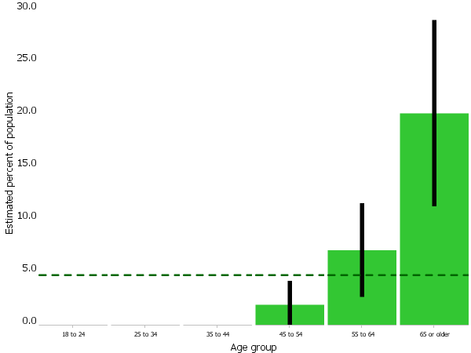The burden of heart disease in Strafford County is great. Strafford County ranks third out of 10 counties in the number of adults diagnosed with, and hospitalized for, coronary heart disease,5.65 percent and 18.19 per 10,000admissions respectively (Figure 5)[96]. Just as alarming is the burden of stroke in Strafford County, which is significantly higher than the rest of the state. From 2009-2013, Strafford County had the highest rate in the state for hospital admissions attributable to stroke[97] (Figure 6) and third highest rate for stroke mortality (204 deaths)[98].

Figure 5: Coronary Heart Disease Prevalence, 2013

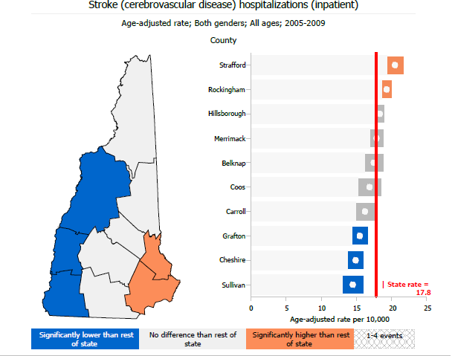Strafford County ranks poorly also for the number of adults reporting having high blood pressure, being obese, smoking cigarettes, having high cholesterol levels, and being physically inactive[99].For example, 19 percent of adults report smoking cigarettes,23 percent report being physically inactive, and31 percent report being obese[100].

Figure 6: Stroke Hospitalizations 2005-2009

Over 33 percent of adults between the age of 55 and 64 reported having high blood pressure. The rate significantly increases for people age 65 years and older to reporting having high blood pressure (Figure 7)[101].

To better understand how Heart Disease and Stroke is perceived by the community, two focus groups were conducted at:

* The Homemakers Health Services Day Out program

Figure 7: High Blood Pressure Awareness (Adults) 2013

* 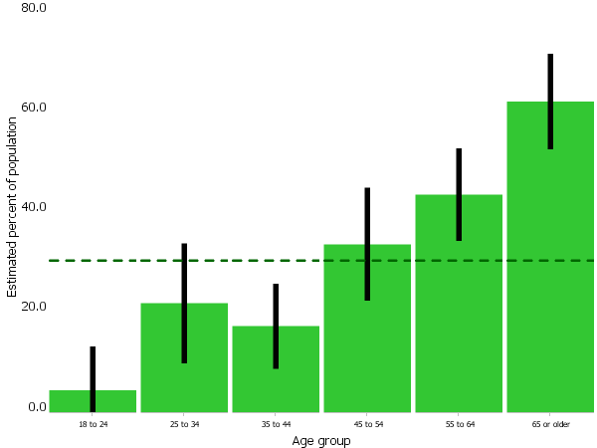St. Ann Senior Living Center – Bishop Gendron Apartments

In total 28 participants – 25 women and three men age 60 years and older – were asked questions about heart disease and stroke prevention. Sixty percent of the participants have been diagnosed with heart disease and/or have had a stroke. Given that the majority of the participants have a history of heart disease most were able to identify preventative measures to reduce risk. Responses included:

* Maintain a healthy lifestyle
* Exercise and stay active
* Eat healthy food choices
* Have cholesterol and blood pressure screened
* Regular visits with doctor

Similar responses were provided when asked how to prevent stroke with the addition of: understanding and recognizing the signs and symptoms of stroke.

Participants listed only two resources they were aware of to prevent heart disease and stroke: access to health care providers and transportation.

Barriers that prevent seniors from reducing risks include self-knowledge of health related emergency was primary barrier. Even those who had previously had experienced either an emergency to heart disease or stroke, knowledge and awareness remained paramount to extending the chain of life. Other barriers include expenses and cost of care, transportation, and hereditary issues.



# Regional Assets

The following organizations are those “assets” to address Heart Disease and Stroke initiatives:

* Frisbie Memorial Hospital
* Goodwin Community Health Center
* Wentworth-Douglass Hospital
* Community Partners Behavioral Health Center
* The Strafford County Y
* Rochester Child Care Center
* Strafford Regional Planning Commission
* Community Action Partnership of Strafford County

As illustrated in Partner Tool graphic, there are opportunities to engage new, and improve coordination with existing, stakeholder organizations to increase awareness of heart disease and stroke prevention. A “collective impact” fosters accountability among stakeholder organizations to improve population health[102]. Increasing coordination among stakeholder organizations and employing evidence-based protocols in the health care setting can improve overall health and wellbeing.

Presently, several initiatives are underway to reduce the risk of developing heart disease and stroke including integrating the Million Hearts’ “Ten Steps for Improving Blood Pressure Control in the Primary Care Setting” and the American Heart Association’s Go Red for Women initiative.

# Goals, Objectives and Strategic Approach

|  |  |
| --- | --- |
| Goal | **To achieve physically healthy communities by addressing Heart Disease and Stroke in Strafford County.** |
| Objective 1: | **Increase awareness of how to reduce heart disease and stroke in Strafford County by attending at least 5 community events (farmers markets, physicians’ offices, etc.) by the end of FY 19.** |
| Objective 2: | **Increase awareness of best practices to identify risk of heart disease and stroke by distributing 100 information sheets by the end of FY 19.** |
| objective 3: | **Increase knowledge of ways to improve one’s health after a cardiac event or stroke by increasing access to information on services available in Strafford County by 5% to all primary cares and area hospitals by the end of FY 19.** |
| Strategic Approach  STRATEGY 1: Increase our presence in community to increase Strafford County individuals that know of the strafford county public health network and its resources it has to offer.  STRATEGY 2: Collaborate with PHAC partners as well as workgroup members to increase knowledge and education of heart disease prevention, treatment, and rehabilitation availability in Strafford county. | |

# Summary

Objective 1**:** Increase awareness of how to reduce heart disease and stroke in Strafford County by attending at least 5 community events. These events can include health fairs, farmers markets, as well as school kick offs and orientations. Workgroup partners as well as PHAC think that having more of a presence in the community can help to open doors to the communication that needs to happen to increase knowledge to citizens.

Objective 2: Increase awareness of best practices to identify increased risk for heart disease and stroke by distributing 100 information sheets by the end of FY 19. Information sheets will includes details of how to prevent your risk of a heart disease and stroke, local treatment facilities, and services to recover and continue to lead a heart healthy life after a cardiac event or stroke. After developing the information sheet, we will then look to see where gaps lie to help patients navigate to the closest service.

Objective 3: Increase knowledge of ways to improve one’s health after a cardiac event or stroke by increasing access to information on services available in Strafford County by 5% to all primary cares and are hospitals by the end of FY 19. With only two local hospitals in a concentrated area in Strafford County, it is a distance to the next hospital that may or may not offer cardiac rehab. Our Workgroup hopes to help educate citizens of what is offered in their area to help them to utilize those services.

# Appendix A: Substance Misuse Prevention, Treatment, and Recovery

*Strafford County Public Health Network*

*FY 18 Community Health Improvement Plan Priority*

**SFY18 Work plan and Evaluation Plan**

**Mental Health**

|  |  |  |  |
| --- | --- | --- | --- |
| **Goal**  *(from Community Health Improvement Plan)* | Strength coordination and communication among community health partners to support Substance Misuse prevention, treatment and recovery initiatives. | | |
| **Problem Statement:** | Approximately 105,000 individuals (9% of the population over 12 years of age) in New Hampshire meet the American Psychiatric Association (APA) diagnostic criteria for substance use disorders (SUD). In addition to a public health crisis, substance misuse is also an economic toll. As the number of overdoses rises and more and more money is used for substance misuse, we need to approach substance misuse in a way that will increase education, services and provide equity to high risk populations. | | |
| **Objective 1** | Increase education and development opportunities in the area of prevention in Strafford County by providing 4 different educational platforms by the end of FY 19. | | |
| **ACTIVITIES** | **SHORT TERM PERFORMANCE TARGETS** | **INTERMEDIATE PERFORMANCE TARGETS** |
| Partner with the New Hampshire Teen Institute to provide an evidence based parent education program in Strafford County | Reach out to teen institute to develop relationship as well as begin conversation around parent education program | Develop and plan parent education program to unveil in Strafford County. |
| Coordinate family & parent information events within Strafford County | Determine dates and subject matter for parents events as well as keynote speakers. | Make flyers and publish events on a variety of media avenues. |
| Host six Lunch and Learn Events with local businesses to promote effective prevention strategies in the workplace | Determine subjects for lunch and learns as well as businesses to approach | Set all lunch and learn dates and subjects and add to community calendar |
| Coordinate community and school awareness events and speaking opportunities | Identify speaking topics to approach appropriate schools with opportunity | Develop speaking material for schools and determine date and times. |
| **Objective 2:** | Use continuous updating of information and dissemination to distribute a total of 1,000 resource guides at community events and activities in Strafford County by end of FY 19. | | |
| **ACTIVITIES** | **SHORT TERM PERFORMANCE TARGETS** | **INTERMEDIATE PERFORMANCE TARGETS** |
| Update resource guides bi annually (summer and winter) | After guides are updated internally, print 500 guides bi annually (summer and winter) | Distribute guides to key sectors (SOS recovery, Wentworth Douglass, and Frisbie) as well as website, Facebook, Newsletters, and have on hand for request from partners. |
| **Objective 3:** | Increase the number of recovery coaches with Motivational Interviewing training by collaborating with partners to host at least 2 MI trainings in Strafford county by the end of FY 19. | | |
| **ACTIVITIES** | **SHORT TERM PERFORMANCE TARGETS** | **INTERMEDIATE PERFORMANCE TARGETS** |
| Collaborate with SOS recovery community to implement trainings for recovery coaches. | Have dates for upcoming trainings set as well as material for meetings. | Increase the number of CRSW comfortable with Motivational Interviewing to shift practices to a more in-depth service. |

# Appendix B: Mental Health

*Strafford County Public Health Network*

*FY 18 Community Health Improvement Plan Priority*

**SFY18 Work plan and Evaluation Plan**

**Mental Health**

|  |  |  |  |
| --- | --- | --- | --- |
| **Goal**  *(from Community Health Improvement Plan)* | Strength coordination and communication among community health partners to support Mental Health Initiatives. | | |
| **Problem Statement:** | Mental health status is essential to personal wellbeing, interpersonal relationships, and being a productive employee in the workplace and member of the community. Persons with a mental illness have an increased risk of engaging in risky behaviors such as smoking, binge drinking, and not exercising. As a result, a person with a mental illness is at an increased risk for having co-occurring substance use dependence as well as developing chronic health conditions | | |
| **Objective 1** | Increase training opportunities among partners and the Public Health Network from 0 to 5 for all individuals in Strafford County regarding Mental Health awareness and prevention by the end of FY 19. | | |
| **ACTIVITIES** | **SHORT TERM PERFORMANCE TARGETS** | **INTERMEDIATE PERFORMANCE TARGETS** |
| Organize CONNECTS trainings ( 1 per FY) targeted to Young Adults in Strafford County | Determine date and time of location to begin to recruit young adults to attend workshop | Stay connected with Young Adults to become ambassadors in the County for other young adults to get more involved |
| Identify gaps of educational opportunities in Strafford County ( ex: Trauma informed care, self- care/ compassion) to be able to provide more trainings in those areas. | Find out what is already offered in Strafford County to then find other trainings that may be able to be offered. | Develop training calendar of events for the remained of FY 18 and all of FY 19 to distribute across Strafford County |
| **Objective 2:** | Increase the percentage of patients screened for a mental health illness at Goodwin Community Health in Strafford County by 5% by the end of FY 19. | | |
|  | **ACTIVITIES** | **SHORT TERM PERFORMANCE TARGETS** | **INTERMEDIATE PERFORMANCE TARGETS** |
|  | Cori will attend Goodwin Community Health CQI meetings to stay informed on measures and progress. | If measure seems to be declining, work collaboratively with clinical to find out why | Once informed of barrier, help clinical staff to meeting goal with interventions. |
| **Objective 3:** | Increase number of support groups offered in Strafford County for individuals that struggle with a Mental Health illness by 1 by the end of FY 19. | | |
| **ACTIVITIES** | **SHORT TERM PERFORMANCE TARGETS** | **INTERMEDIATE PERFORMANCE TARGETS** |
| Assess current support groups offered in Strafford County to then be able to identify gaps of interest. | Determine new support groups to partner with organizations to begin to host to public. | Develop a support group calendar of support groups offered for the remained of FY 18 and all of FY 19 to distribute across Strafford County. |

# Appendix C: Obesity and Nutrition

*Strafford County Public Health Network*

*FY 18 Community Health Improvement Plan Priority*

**SFY18 Work plan and Evaluation Plan**

**Obesity and Nutrition**

|  |  |  |  |
| --- | --- | --- | --- |
| **Goal**  *(from Community Health Improvement Plan)* | To promote physically healthy communities by addressing obesity and improving nutrition in Strafford County. | | |
| **Problem Statement:** | Obesity is a chronic health condition primarily attributable to behavioral risk factors such as poor diet and physical inactivity. It is a serious public health problem in New Hampshire, where one in four adults is obese (BMI > 30). While poor nutrition and lack of physical activity are often cited as the cause, obesity is a complex condition in which a multitude of influences is at play. What a person chooses to eat is a behavioral choice but also an economic one. Lower education attainment and income levels are strongly associated with obesity in New Hampshire | | |
| **Objective 1** | Maintain an obesity and nutrition workgroup with at least 5 active members | | |
| **ACTIVITIES** | **SHORT TERM PERFORMANCE TARGETS** | **INTERMEDIATE PERFORMANCE TARGETS** |
| Increase the coordination and collaboration of healthy eating and physical activity initiatives throughout Strafford County | Establish a comprehensive list of initiatives organizations are currently working towards throughout Strafford County | Partners collaborate on at least one new initiative in Strafford County |
| Increase number of partners and organizations attending the ONHDS workgroup | Compose a comprehensive list of all potential partners and what they can bring to the ONHDS workgroup | Increase collaboration of partners , attendance at workgroups, and initiatives that the ONHDS workgroup participates in |
| **Objective 2:** | Distribute 3 platforms that provide education on healthy living by the end of FY 19. | | |
| **ACTIVITIES** | **SHORT TERM PERFORMANCE TARGETS** | **INTERMEDIATE PERFORMANCE TARGETS** |
| Obtain and distribute to local businesses breastfeeding friendly workplace tool kit guides. | Obtain breastfeeding tool kit as well as compose a comprehensive list of businesses and business sectors that are the most high need | Visit and give education to 50 businesses in Strafford County in a variety of sectors about how to be a breastfeeding friendly workplace. |
| Provide free quarterly cooking classes that are open to the public and give education on healthy eating, physical activity and cost saving. | Apply and obtain additional funding to host cooking classes in a variety of locations | Set all cooking class dates, locations, and times for the remainder of 2018. Look for additional funding to give participates prizes and incentives for attending. |
| Distribute at schools, primary cares, and other key locations 5-2-1-0 placemats and magnets to educate public on health recommendations for healthy eating and active living for youth and adults. | Work closely with NH Healthy Families and Wellsense (funders for printing material) to order supplies for dispensing. | Work with workgroup to determine key locations to distribute in Strafford County. |
| **Objective 3:** | Collaborate on at least 1 new initiative that increases the availability, accessibility and uptake of healthy foods by 2019 | | |
| **ACTIVITIES** | **SHORT TERM PERFORMANCE TARGETS** | **INTERMEDIATE PERFORMANCE TARGETS** |
| Identify additional potential stops for the SAMM van in more rural communities. | Identify locations in rural towns that could host SAMM van | Help to facilitate discussion among partners for SAMM van stops to help to increase opportunity in rural towns |
| **Objective 4:** | Collaborate on at least 1 new initiative that increases the availability, accessibility and use of free/low cost physical activity by 2019. | | |
| **ACTIVITIES** | **SHORT TERM PERFORMANCE TARGETS** | **INTERMEDIATE PERFORMANCE TARGETS** |
| Collaborate with local gyms and recreation centers to host an “open gym” day for all. | Reach out to all gyms (The Works, Planet Fitness, YMCA in Rochester, ect) to see if they are willing to host an open gym day | Determine one day a year that all participating facilities will host “open gym” day for all to enjoy physical fitness for free. |

# Appendix D: Emergency Preparedness

*Strafford County Public Health Network*

*FY 18 Community Health Improvement Plan Priority*

**SFY18 Work plan and Evaluation Plan**

**Emergency Preparedness**

|  |  |  |  |
| --- | --- | --- | --- |
| **Goal**  *(from Community Health Improvement Plan)* | Build community resilience through increased partner involvement and to strengthen and sustain public health and emergency response systems. | | |
| **Problem Statement:** | Results from the 2013 New Hampshire BRFSS Survey on Emergency Preparedness indicate that 32.2 percent of adults believe they are well prepared to handle a large-scale disaster or emergency, while 53.6 percent were somewhat prepared and 14.1 percent were not prepared. Public health threats are always present and citizens need to know how to respond and who to contact in a state of emergency to ensure their safety. | | |
| **Objective 1** | Increase integration of key stakeholders and organizations to build capacity to support public health efforts related by having a minimum of 6 partners attend quarterly meetings. | | |
| **ACTIVITIES** | **SHORT TERM PERFORMANCE TARGETS** | **INTERMEDIATE PERFORMANCE TARGETS** |
| Send out letters to all partners with updates of | Develop a template to easily edit from when developing letters for partners | Use letters to update partners on progress of goals and objectives as well as upcoming events and activities to be involved in. |
| Make a calendar to show all meetings for the remainder of FY 18 and then FY 19 | Develop a calendar with all meeting dates for the remainder of the year to help partners to get in a routine of when and where meetings are held. | Once a calendar is made, make sure to post in all newsletters, meeting agenda packets, and email correspondents to continue common messaging. |
| **Objective 2:** | Identify and initiate Medical Countermeasure dispensing strategies 5 times by the end of FY 19. | | |
| **ACTIVITIES** | **SHORT TERM PERFORMANCE TARGETS** | **INTERMEDIATE PERFORMANCE TARGETS** |
| Determine PODs that can be exercised before end of FY 19 | Communicate with POD managers of site being considered to exercise and determine a date and time to hold exercise. | Notify proper personnel of exercise taking place to be aware of activity |
| Complete all necessary paperwork to provide to state or partners on POD | Obtain all paperwork that needs to be complete before a POD exercise | After exercise, complete all paperwork and submit to proper personnel. |
| **Objective 3:** | Deliver at least 4 professional development training opportunities to current partners by the end of FY 19. | | |
| **ACTIVITIES** | **SHORT TERM PERFORMANCE TARGETS** | **INTERMEDIATE PERFORMANCE TARGETS** |
| Increase number of trainings and learning opportunities in region to help professionals knowledge of emergency preparedness | Discuss with all partners trainings they need for licenses or have interest in learning more about. | Make a master calendar of when and where trainings are taken place and upload to website, newsletters, as well as in all email correspondents. |
| Survey partners and stakeholders in region to determine trainings they can administer | Develop a survey to give to all partners to help see what trainings they can deliver to the Emergency Preparedness partners | Fill gaps of trainings by looking outside of the region to find a subject matter expert to present. |

# Appendix E: Heart Disease and Stroke

*Strafford County Public Health Network*

*FY 18 Community Health Improvement Plan Priority*

**SFY18 Work plan and Evaluation Plan**

**Heart Disease and Stroke**

|  |  |  |  |
| --- | --- | --- | --- |
| **Goal**  *(from Community Health Improvement Plan)* | To achieve physically healthy communities by addressing Heart Disease and Stroke in Strafford County. | | |
| **Problem Statement:** | Heart disease remains the largest cause of premature death in the United States and is the second leading cause of death in New Hampshire. Strafford County ranks third out of 10 counties in the number of adults diagnosed with, and hospitalized for, coronary heart disease,5.65 percent and 18.19 per 10,000admissions respectively. Just as alarming is the burden of stroke in Strafford County, which is significantly higher than the rest of the state. | | |
| **Objective 1** | Increase awareness of how to reduce heart disease and stroke in Strafford County by attending at least 5 community events (farmer’s markets, physician offices, etc) by the end of FY 19. | | |
| **ACTIVITIES** | **SHORT TERM PERFORMANCE TARGETS** | **INTERMEDIATE PERFORMANCE TARGETS** |
| Coordinate and collaborate with workgroup members to disseminate resources for Million Hearts Campaign | Select Strafford County primary care sites to partner with and distribute appropriate resources for their consumers | Distribute at least 250 resources by the end of FY 19 |
| Prioritize community events to determine which ones are most fit to attend and what resources and activity will be given | Develop resource (s) to use when at community events | Attend events with workgroup members to inform community of who/ what behaviors are at high risk and how to stop |
| **Objective 2:** | Increase awareness of best practices to identify increased risk for heart disease and stroke by distributing 100 information sheets by the end of FY 19. | | |
| **ACTIVITIES** | **SHORT TERM PERFORMANCE TARGETS** | **INTERMEDIATE PERFORMANCE TARGETS** |
| Collaborate and coordinate efforts to compose a comprehensive list of all preventative, treatment and recovery setting in Strafford County. | Determine lay out for information sheet as well as obtain all information and resources for it. | Find and have workgroup approve information sheet. Begin to distribute at least 250 sheets by the end of FY 19. |
| Develop and administer individualized surveys for all individuals approaching our booth at events with a survey to find out how at risk they are and techniques to lower that risk | Find a evidence based survey to administer to interested individuals | Work with partners to develop a list of ways to improve if you are an at risk individual. |
| **Objective 3:** | Increase knowledge of ways to improve one’s health after a cardiac event or stroke by increasing access to information on services available in Strafford County by 5% to all primary cares and area hospitals by the end of FY 19. | | |
| **ACTIVITIES** | **SHORT TERM PERFORMANCE TARGETS** | **INTERMEDIATE PERFORMANCE TARGETS** |
| Find gaps for care for patients that are post stroke or post heart disease diagnosis and collaborate with current and future partners to fill those gaps | Research and compose a comprehensive list of all organizations that are serving individuals post stroke or heart disease. Determine what services they provide and what gaps exist in Strafford County | Increase knowledge of patients about what is available as well as begin to increase collaboration of gaps that need to be addressed for proper care. |

# APPENDIX F: Asset and Gap Inventory from 2015-Refer to PDF

|  |  |  |  |  |  |
| --- | --- | --- | --- | --- | --- |
| **Existing Strategies/Actions** | | **Strengths/Assets** | **Barriers/ Challenges** | **Proposed Strategies/ Activities** | **Stakeholders and Resources** |
| **Substance Misuse: Prevention, Treatment and Recovery** | | | | | |
| **1.** Increase the coordination of treatment and recovery of stakeholder organizations by 5% in three years. | | | | | |
| Youth education/prevention | MAT | DFC Funding | HLOC | #1 Workforce development- license issues | SENHS |
| Parent education/prevention | AA/NA (12-Step) | Stop Act | Stigma | #2 Dual diagnosis treatment- inpatient youth and adult | Police |
| Drug taskforce | Bonfire | Drug Court | Media coverage | #3 Community resource center/recovery support center youth and adult (all resources in place FJC model) | Schools |
| PeopleCare - Farmington | Triangle Club | Community Benefits | Provider support/ancillary support |  | Medical providers |
| L.O.A | HOPE | Juvenile Justice | Outreach |  | Local businesses |
| Youth to Youth | IOP Alumni group | Private Insurance | Silo |  | Church |
| Community commissions | 12-Step Yoga | Public Health | Crisis phone |  | Family |
| Rec. Department after school program | SENDHD | SAMSAA | Chronic absenteeism |  | Advocacy |
| Prescriber education | ROAD (IOP, MAT) | NH Charitable Fund | Tx facilities | DARE - All schools | Courts |
| Child sexual abuse/SASS | Cocheco counseling | S.V. prevention | Prison program/re-entry | Lunch and Learns | Hospital |
| ASAP | Merrimack Valley (M+D) | EAPs | RSS for women | Job assistance/adolescents | Funders |
| Teen/adult drug court | Outpatient Counseling | TANF | Childcare | Use media to discuss SUD | Bonfire |
| Mental health court | NHEP | Nonprofits | Transportation | F/U wellness | Politicians |
| Brief intervention | REAP | Bridging the Gap Rochester Community Coalition for Alcohol and Drug Dependence | Prevention services - early childhood education | Comm/committee/SUD | Lawyers |
| CFS probation/parole | Home visiting/DCYF |  | Access to treatment | Coordinated Care | Media |
| Head Start | REAP at Community Partners (older adults) | In shape= Healthy Choices/Changes | Single payer | Outreach board provider ED/PCP | Probation/parole |
| Primary Care |  |  | Family support |  | Drug industry |
| Care coordination |  |  | RSS for adolescents |  | MH |
| EMS |  |  | Treatment for adolescents |  | New Future |
| CIT |  |  | Provider development for recovery and treatment |  | Pharmacies |
|  |  |  | Domestic and sexual abuse |  | HOPE |
|  |  |  |  |  |  |
|  |  |  |  |  |  |
|  |  |  |  |  |  |
| **Mental Health** | | | | | |
| Education | MH Peer Support | Community Partners in Schools | Stigma | Educate youth on how to effectively manage emotions |  |
| Safe Schools, Healthy Students | Clear Path Program (Homemakers) | Homecare agencies | Push back from school boards and parents | Media campaign on MH* |  |
| **Existing Strategies/Actions** | | **Strengths/Assets** | **Barriers/ Challenges** | **Proposed Strategies/ Activities** | **Stakeholders and Resources** |
| Youth Peer Groups i.e. Youth to Youth | Adult | Rochester Rec. Programs | Elder isolation | MH Specialists in primary care |  |
| Mental Health Wellness Programs - Businesses | MH Court | Social workers in primary care | Lack of access to physical ed | #1 Educate all school aged youth |  |
| NH Guard Program | MH Respite Housing | SCPB | lack of resources | #2 MH IOP with transportation |  |
| Mental Health First Aid | EAP | Social workers in schools | Lack of access to information and training for parents | #3 Mentoring youth program |  |
| Engagement of Insurance industry | CFS | Rochester Housing Authority | PCs practicing beyond scope |  |  |
| PPIS Models | SAP | SASS, A Safe Place | Competing policies/procedures between agencies i.e. police |  |  |
| Portsmouth support programs i.e. include teacher support | MH Court- Felony Level | CAP | Wait time for interventions |  |  |
|  | Geri psych unit | Mental Health First Aid | Communicating assets/coordination | Educate medical community re: MH - use consult model i.e.  MIA |  |
|  | Integrated BH and primary care | Tri City CO-OP | Environmental stressors | Mental Health First Aid for Strafford County |  |
|  | CHINS Strafford County | CIT Team | Family/community engagement | Data mine successful population- based screening and preventions |  |
|  |  | Safe Schools/ Healthy Student Grant in Rochester | Access to health coverage | Engage business community |  |
|  |  | Healthy Choices, Healthy Changes | Payors/insurance companies | Improve transition process from ER to appropriate treatment i.e. IOP, inpatient beds |  |
|  |  | Family Justice Center |  |  |  |
| **Obesity and Nutrition** | | | | | |
| WDH: sweetened beverages ban on campus |  | The Works Fitness Center and YMCA | Lack of transportation to fitness facilities | 1. Continue to build a HEAL coalition. Activities: I. Create a workgroup to broaden the network to implement HEAL programs/initiatives |  |

|  |  |  |  |  |  |
| --- | --- | --- | --- | --- | --- |
| **Existing Strategies/Actions** | | **Strengths/Assets** | **Barriers/ Challenges** | **Proposed Strategies/ Activities** | **Stakeholders and Resources** |
| Health Families Home Visiting Program (CAP) |  | Partners in Health community partners | Lack of knowledge i.e. parks | 2. Increase free/low cost phyisical activity opportunities. Activities: I. Outreach to conservation commissions in the community to identify opportunities to access space for recreational purposes. II. Increase access to fitness programs in the community. |  |
| Grown an Extra Row for Pantries (CAP) |  | Rochester Childcare | No longer 21st Century Program | 3. Improve youth nutrition through expansion of existing program and school policies. Activities: I. Coordinated School Health Program to change/strengthen policies and programs. II. Expand early education programs. III. Outreach to community leaders with data to affect policy changes (framing importance: economically and socially). |  |
| Summer Meals Program (CAP) |  | UP Program- after school program | Outreach to parents |  |  |
| Comm health edu lectures at FMH |  | People/orgs researching and identifying walkability | Commodity food options |  |  |
| Recipe of the month, healthy meal class at FMH |  | CAP | End 68 Hours of Hunger nutrition |  |  |
|  |  | Community Gardens | Kids don't like "healthy" food |  |  |
|  |  | Meals on Wheels | School snacks/food |  |  |
|  |  | Summer vacation meals 0-19 | Lack of physical activity |  |  |
|  |  | Rotary Club | EBT cards wrong incentives |  |  |
|  |  | Farmers Markets | Need lower cost food providers |  |  |
|  |  | Seacoast Early Learning Alliance | Geographic challenge |  |  |
|  |  | Schools | infrastructure challenge |  |  |
|  |  | After School Programs | No cheap, accessible winter outdoor rec |  |  |
|  |  | Coop extension NH food strategy |  |  |  |
|  |  | 68 hours of hunger program |  |  |  |
| Meet ups: reg. gardening | | | | | |
| **Emergency Preparedness** | | | | | |
| **Existing Strategies/Actions** | | **Strengths/Assets** | **Barriers/ Challenges** | **Proposed Strategies/ Activities** | **Stakeholders and Resources** |
| **1**. Increase the integration of key stakeholder organizations by PHN that engage in PH emergency planning, training, exercising, and responding. **2**. Increase the emergency public information and warning capability among stakeholder organizations from 30% to 37%. **3.** Increase the number of schools of students receiving the influenza vaccine clinic from 16 to 18. | | | | | |
| Community Resilience and Recovery | Public education to inform and prepare individuals and communities.  Support services network for long- term recovery.  Emergency public information and warning.  Local social networks for preparedness and resilience.  Public engagement in local decision making  Integrated Support from NGOs Post Incident social network re- engagement  Case management support | FMH/WDH  Structural Facilities Paid Full Time Staff HSEM  Large Knowledge Base Outreach  Emergency Preparedness Task Force NGOs  Operational Awareness Technology | Money Stakeholder buy-in Time/Priorities  Mindset of working Regionally Part-time Unpaid Staff Comfort Level Education/Mentorship Vulnerable Populations  Don't understand Value | Public education to inform and prepare individuals and communities.  Emergency public information and warning.  Continuity of Operation Planning (COOP).  Recovery Exercises.  D | Existing resource Supply Chains  EPT Membership EMDs, Fire/Police, Department Heads, FMH/WDH, HHCs, CERT/MRC |
| Infrastructure | Support services network for long- term recovery. | Interoperable and resilient communications systems. Generators Installation/Function. | Private contractors Existing resource Supply Chains  EPT Membership EMDs, Fire/Police, Department Heads, FMH/WDH, HHCs, CERT/MRC |
| Situational Awareness | Risk assessment and risk management.  Monitoring of available resources. Epidemiological Surveillance & investigation.  CBRNE | Risk assessment and risk management.  Monitoring of available healthcare networks. | EMDs, Fire/Police, Department Heads, FMH/WDH, HHCs |
| Incident Management | Local social networks for preparedness and resilience. | ICS Education, Training and Exercising. |
| Disease Containment and Mitigation | Management and distribution of medical countermeasures. | Educating Stakeholders  Personal Protective Equipment Management and distribution of |
| School Flu | Implementing and evaluating school based influenza clinics. | Personal beliefs, Religion, Language, Reimbursement Models, Education, State Policies, Staffing, Money | Implementing and Evaluating school based influenza clinics. Vaccination Education.  Community Clinics. | CERT/MRC, Fire,  HCCs Staff |
| **Existing Strategies/Actions** | | **Strengths/Assets** | **Barriers/ Challenges** | **Proposed Strategies/ Activities** | **Stakeholders and Resources** |
| **Stroke and Heart Disease** | | | | | |
| Million Hearts with Community Partners |  |  |  | 1. Expand million hearts campaign throughout the community. I. Engage community stakeholder organizations. |  |
| Homemakers: Know your Numbers campaign |  |  |  | 2. Increase access to chronic disease self-management programs (e.g. better choices better health). I. Look into a partnership w/FMH, WDH, YMCA, etc. |  |
| FMH: Go Red Breakfast |  |  |  |  |  |

1. (County Health Rankings and Roadmaps, 2015)
2. (United States Census Bureau, 2015)
3. (ibid)
4. (ibid)
5. (County Health Rankings and Roadmaps, 2015)
6. (ibid)
7. (ibid)
8. (ibid)
9. (United States Census Bureau, 2015)
10. (United States Census Bureau, 2015)
11. (County Health Rankings and Roadmaps, 2015)
12. (ibid)
13. (County Health Rankings and Roadmaps, 2015)
14. (ibid)
15. (County Health Rankings and Roadmaps, 2015)
16. (County Health Rankings and Roadmaps, 2015)
17. (New Hampshire Depatment of Health and Human Services)
18. (NH Division of Public Health Services)
19. (NH Division of Public Health Services)
20. (County Health Rankings and Roadmaps, 2015)
21. NH DHHS, 2015
22. # APPENDIX G: Contact Information

    **Cathy Smith, Director of qi and Population Health**

    Strafford County Public Health Network

    *Goodwin Community Health*

    Office: (603)516-2564

    [csmith@goodwinch.org](mailto:csmith@goodwinch.org)

    **Corinna Moskal, Continuum of Care Manager**

    Strafford County Public Health Network

    *Goodwin Community Health*

    Office: (603) 994-6357

    Cell: (603) 748-1217

    [cmoskal@goodwinch.org](mailto:cmoskal@goodwinch.org)

    **Alissa Cannon, Substance Misuse Prevention Coordinator**

    Strafford County Public Health network

    *Goodwin Community Health*

    Office: (603)994-6340

    Cell: (985) 514-4131

    [acannon@goodwinch.org](mailto:dlemire@onevoice.nh.org)

    **Ashley Ciampa, Young Adult Prevention Coordinator**

    Strafford County Public Health Network

    *Goodwin Community Health*

    Office: (603) 749-2346 X 533

    [aciampa@goodwinch.org](mailto:aciampa@goodwinch.org)

    **Mary Kerr**

    Strafford County Public Health Network

    *American Ambulance*

    Office: (603) 480-5600

    [mkerr@americanambulancesvc.com](mailto:aciampa@goodwinch.org)
23. NH DHHS, 2015
24. New Futures 2014
25. New Futures 2014
26. (Institute, 2012)
27. NH Drug Monitoring Initiative, 2015
28. (Currie, 2015)
29. For the purpose of this CHIP, Mental Health is defined as a state of well-being in which the individual realizes his or her own abilities, can cope with the normal stresses of life, can work productively and fruitfully, and is able to make a contribution to his or her community.(Centers for Disease Control and Prevention, Program Performance and Evaluation Office, 2013)
30. (New Hampshire Health and Human Services, 2011)
31. (Substance Abuse and Mental Health Services Administration)
32. (New Hampshire Health and Human Services, 2011)
33. (Substance Abuse and Mental Health Services Administration)
34. (Substance Abuse and Mental Health Services Administration)
35. (Substance Abuse and Mental Health Services Administration)
36. (Centers for Disease Control and Prevention , 2014)
37. (Substance Abuse and Mental Health Services Administration)
38. (New Hampshire Health and Human Services, 2011)
39. (New Hampshire Health and Human Services, 2011)
40. (New Hampshire Health and Human Services, 2011)
41. (O’Grady, 2015)
42. (O’Grady, 2015)
43. (Patrick O, 2015)
44. (Patrick O, 2015)
45. (Ronayne, 2015)
46. (Caroline Buck, 2011)
47. (Lessard, 2015)
48. (National Alliance on Mental Illness (NAMI) New Hampshire)
49. (Lessard, 2015)
50. (New Hampshire Health and Human Services, 2011)
51. (Caroline Buck, 2011)
52. (NH Community Behavioral Health Association, 2015)
53. (County Health Rankings and Roadmaps, 2015)
54. (University of New Hampshire's Institute for Health Policy , 2014)
55. (County Health Rankings and Roadmaps, 2015)
56. (County Health Rankings and Roadmaps, 2015)
57. (NH Division of Public Health Services, 2013)
58. (Third Grade Survey 2013-14)
59. (Finkelstein, 2009)
60. (Cawley J., 2007)
61. (Wilder Research, 2014)
62. (Hannon C., 2006)
63. (Moore, 2008)
64. (County Health Rankings and Roadmaps, 2015)
65. (NH Division of Public Health Services, 2013)
66. (National Center for Education Statistics)
67. Strafford County YRBS Middle School Aggregate Data Report, 2017
68. Accessed [www.healthynh.com](http://www.healthynh.com) on Sept. 20 2015
69. Centers for Disease Control and Prevention , 2005-09
70. US Census Bureau, 2012
71. (NH Division of Public Health Services, 2013)
72. (ibid)
73. (ibid)
74. (Lim, 2015)
75. (ibid)
76. (Lim, Results form the 2013 New Hampshire BRFSS Survey on People with Disability, 2015)
77. (ibid)
78. (Lim, Results form the 2013 New Hampshire BRFSS Survey on People with Disability, 2015)
79. (Lim, 2015)
80. (ibid)
81. (Lim, Results form the 2013 New Hampshire BRFSS Survey on People with Disability, 2015)
82. (ibid)
83. (ibid)
84. (NH Division of Public Health Services, 2013)
85. (Heart Disease Facts, 2015)
86. (Heart Disease Facts, 2015)
87. (NH Division of Public Health Services, 2013)
88. (NH Environmental Public Health Tracking, 2015)
89. (NH Division of Public Health Services, 2013)
90. (Stroke Risk Factors, 2012)
91. (ibid)
92. (New Hampshire Depatment of Health and Human Services)
93. (ibid)
94. (ibid)
95. (ibid)
96. (NH Division of Public Health Services)
97. (NH Division of Public Health Services)
98. (NH Division of Public Health Services)
99. (Heart Disease Facts, 2015)
100. (County Health Rankings and Roadmaps, 2015)
101. (NH Environmental Public Health Tracking, 2015)
102. (New Hampshire Depatment of Health and Human Services)